**Common Disallowed items on School Buses**

Carry-on items: Compliance with federal standards is mandatory by the State Department of Education. No animals, insects, weapons, balloons, glass or pressurized containers or class projects that are large, wooden, etc.-**none of these** are to be carried on busses by drivers, teachers or students. Up to 22x28 paper posters are allowed if driver vision is not obstructed. Band instruments or other items carried on the bus must be of such size that all must be carried in the students lap and cannot be above the seat top. Items on the seats, floor- (projectiles) or obstructing the isles endanger all passengers on the bus. Class projects and large band instruments must be transported to/from school via private vehicle. Secured oxygen tanks are approved for use on Special Needs buses only. Unsecured objects become projectiles upon sudden stops.

School bus drivers are instructed to stop such items from being brought onto the bus. Every item/object must be scrutinized. Students/parents must present items to the school principal for a principal’s signature-note, which must be given to the bus driver prior to approaching the bus.

**Some examples of disallowed items are:**

**Over Sized band Instruments Pressurized/Flammable Items Possible Projectiles**

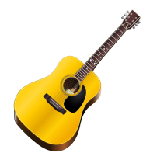 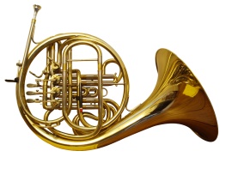 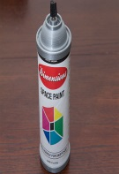 

**All Glass Items Balloons/Flower Bouqets** 

**Possible Weapons Large Class projects Traveling/Camping Items**