# Sullivan Middle School

# School lmprovement Council

# Meeting

# NOTES

Tuesday, September 15, 2020 5:30 – 6:30 pm Zoom Meeting Link

Members present: Kelly Scott (parent), Laura Lawson (parent), Montrio Belton (parent), Dr. Juan Roldan (Principal), Gwen Lindsey (Asst Principal), Shana Hannibal (Asst Principal), Darlene Del Vecchio (Teacher), Rebecca Wren (parent), Mona Letigio (parent), Donna Mack (teacher) and Holly Stuart (teacher)

Mrs. Kelly Scott called the meeting to order at 5:30pm.

First order of business was to approve the last meeting notes in May 2020.

Kelly welcomed everyone back for the new year, 20-21 and announced a congratulations to Dr. Roldan who received his Doctor of Education over the summer of 2020 from Wingate University. She then asked Dr. Roldan to give a school update.

**News**: Dr. Roldan shared this message with the group: School doesn’t feel the same without all of learners in the building. We miss our virtual, we miss having students here every day. Operating under a new normal, doing the best that we can. Expressed thanks to Ms. Del Vecchio and Ms. Culbreath. Everyone (staff) in the building has hybrid roles for the students’ benefit. There has been a smooth start the school year in terms of safety, buses running on time, everyone is still adjusting to the face-to-face C A/B schedule. Some kids confused on days to be there on Monday. We just finished up one official first week of school, teachers & staff spent time focusing on relationships. Right now, a little over 400 kids are doing virtual, 600 are attending in person, 300 per day on each school day.

Since we’re in the middle of a global pandemic, it is likely that someone will be exposed or contract Covid. When this happens, we will follow CDC/DHEC recommendations. The district office has created a dashboard showing numbers of the schools with cases in our district. Given our high enrollment numbers, you will probably see Sullivan on the dashboard. It doesn’t mean we have confirmed cases, but we will have quarantined students/staff. The dashboard is real time. This is a new challenge for us going forward, staff and students being quarantined routinely when necessary. It is only a matter of time before it will affect operations, so we are being positive and hopeful that we can sustain with what we have. We are all adhering to masks & safety policies. Goal is always to return to full 5 day in person education. Virtual Academy is here to stay in district regardless. Some students will excel in virtual and some excel in f2f.

This will also be the first week of curriculum & content. MAPs testing happened for virtual students too. Major issues right now with technology. Repairs & tech problems have been big. Some challenges w hotspots. Principal is pursuing these hotspot issues. We will all struggle for a bit but we are working with district in that.

It doesn’t feel like a typical middle school, but it is functioning. In some cases, we are catching up kids who are behind from last spring. We have the opportunity for more individualized learning. Mrs. Del Veccio and some teachers worked this summer on the school culture. Mrs. Del Vecchio spoke about faculty book study, **Closing the Attitude Gap: How to Fire Up Your Students to Strive for Success**, by Principal Dr. Kafele and over 85% teachers completed it on their time. Point of book to improve student achievement and student success we have to show evidence that we recognize and see them who they are as achievers and the ability to succeed and to give them confidence and tools to achieve. Faculty had interactive activities to work on with book study.

Dr. Roldan then asked 8th grade science teacher, Ms. Holly Stuart to report on her new faculty led initiative, to discuss origin and how it’s going so far. She mentioned the desire for them as faculty and staff to talk about and address social issues and for them to not shy away from tough issues and discuss these with positivity through the role models & adults in their lives. Goals include them to be safe sounding boards for the students, also for the faculty & staff to look at ourselves first and see where we are; to be intentional in helping everyone the same, regardless of perceived or unknown backgrounds. To identify possible implicit bias in themselves as faculty & staff and learning as much as we can to not bring negative things into our classroom and to motivate us to do something about things that we can. Finally, to make sure we have conversations with all of the students and not just when something happens and with not just certain demographics. Not just with black and brown faculty, but everyone by ignoring cultural bias. We are getting an incredibly diverse faculty and we should make sure we are having these conversations. Ms. Stuart said support was immediate from faculty in response. They now have a committee of over 30 signed up and they are calling it the Sullivan Middle School Diversity Committee. Further ideas are that this committee is working on a culture in the school where there are safe spaces for conversations and adding a student sub-group to address their thoughts and ideas, and give them voice. The committee will meet throughout the year school wide.

Dr. Roldan said: It is the hope to meet the students where they are.

Dr. Roldan then addressed the new hiring for the 20-21 school year. The administrators worked hard to fill out vacant positions, and filled all but one. He said regarding faculty and staff, that diversity is our strength and our opportunity for growth. Energy & momentum is here. As to Virtual Academy, we didn’t want to lose teachers, but we did lose some teachers to the academy. Students win but we miss them here for our students at Sullivan.

Next Tuesday is 11th day of school and any students who haven’t appeared for 10 consecutive days will be dropped. A snapshot census of enrollment will be taken. Currently our school is full. We can’t take on any more students at this time with social distancing in place. They may have to be re-directed to other middle schools. We have the highest in person enrollment. We have also been a little restricted on what we can open to virtual students for electives. Counselors have worked very hard to make it work. Electives have been one of our biggest hurdles with the fact that we have two school choices at Sullivan. Everyone is working as team to make it work as well as possible.

Kelly Scott brings up NAMI and their walk which is at. Please join us.

Report to the parents was discussed. Nov 1 deadline. It gives goals actions & outcomes.

Partnerships & Sullivan awards highlighted too.

Pta Sullivan Masks & hoodies & Panera breakfast . Spirit night coming up.

Ringer offered any assistances to school from obc , let us know.

Athletics - will go on. Football in district stadium . Volleyball will be in gym w max of 80 spectators to watch. Respect social distance.

Always looking for community partners. From outside school community.

Next mtg date.

Question from member addressed about sports & social distancing.

How do kids get to district to play sports - help me understand the logic -

Why are virtual students playing too

Dr Roldan responded to question.

**Academics**:

Mrs. Scott talked about the Report to the Parents that is due November 1st. The report was shared with everyone prior to the meeting and a few members had emailed some comments. The group went over a few of the highlights of the goals and outcomes the group worked on last academic year. The report is attached to the end of these notes. All the comments were acknowledged and the final draft was accepted by everyone. Dr. Roldan congratulated and thanked the group for the report. It will be shared online and in paper format.

PTA update was given by Mrs. Laura Lawson.

* 1. Did breakfast for teachers
  2. Created and distributed face picture buttons
  3. Donated Sullivan spirit wear
  4. Looking for Parent Volunteers
  5. PTA also created some attractive photo buttons so that teacher’s faces can be shown to students’ to help them feel more comfortable seeing the student’s faces instead of masks.

Health and Wellness: Kelly Scott reported that the SIC is

. Set next meeting date August 20, 2019 at 5:30 – 6:30. Meeting adjourned at 6:01 p.m.

1. Welcome to allKelly (1 min)
2. Approve last month’s (May 2019) meeting notes Kelly (1 min)
3. School News Dr. Roldan (25 min)
   1. Academics-Start of year

(Partnership w OBC-Notes w gc to teachers & school supplies)

* 1. Student Life
  2. Teachers/Staff Well Being-NAMI Walks on 10/10

1. Report to the Parents is due to SC SIC Nov 1-and will be published & distributed by SIC Kelly
2. PTA Update Laura
   1. Did breakfast for teachers
   2. Created and distributed face picture buttons
   3. Donated Sullivan spirit wear
   4. Looking for Parent Volunteers
3. Set next mtg date which will be October 20th at 5:30pm by Zoom
4. Adjourn

Mtg was adjourned at 6:45. Materials from CFEC rep Julia Beaty were shared after the meeting by email.

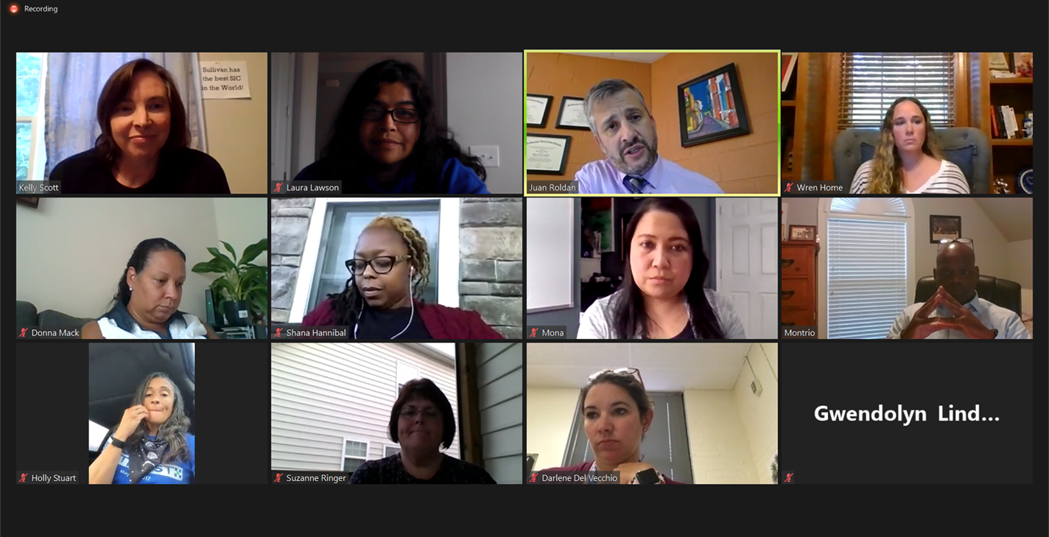

Some of our hard working group!

Attachment:

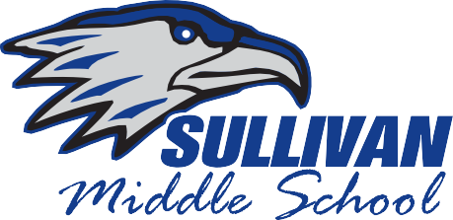

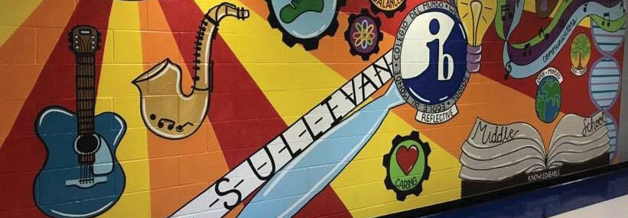**Report to the Parents 2019-20 1825 Eden Terrace, Rock Hill, SC 29730**

**Phone: 803-981-1450**

**Fax: 803-981-1456**

[**https://www.rock-hill.k12.sc.us/sms**](http://www.rock-hill.k12.sc.us/sms)

Sullivan Middle School is a Middle Years International Baccalaureate program school in the Rock Hill School District. We pride ourselves on providing an education that goes beyond the standards of academics.

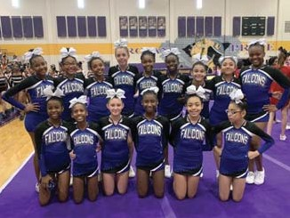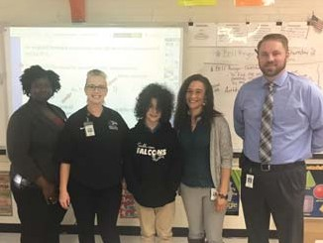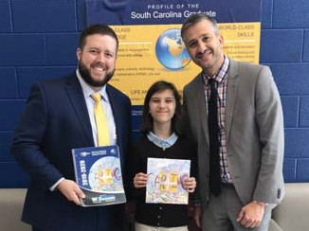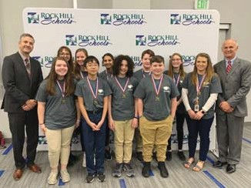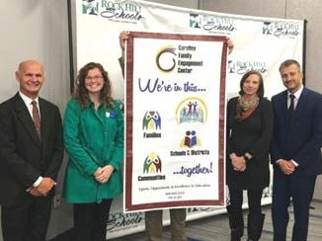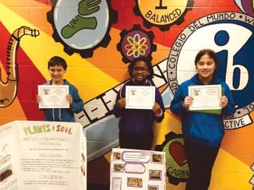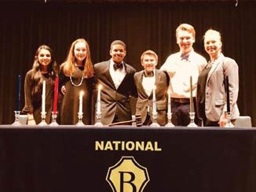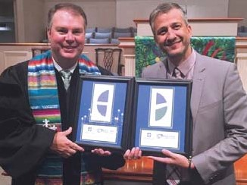

We are preparing our students to be leaders of our future. We strive to build relationships ﬁrst through the IB Learner Proﬁle Qualities: Caring, Reﬂective, Principled, Communicators, Inquirers, Open-Minded, Risk-Taker, Knowledgeable, Thinkers, and Balanced. We are building change makers in the world.

Sullivan trains teachers as nationally recognized International Baccalaureate educators and encourages them to be a voice in the ﬁeld of education. We oﬀer a unique combination of IB and Dual Language Immersion.

Sullivan Middle School will provide a safe learning environment in which faculty and families support and encourage lifelong learning to create and foster physical, emotional, intellectual and social growth, inspiring students to be responsible, productive citizens of the world community.

**Principal: Dr. Juan Roldan ~ Assistant Principals: Shana Hannibal • Gwendolyn Lindsey • Graham Thomas**

|  |  |  |
| --- | --- | --- |
| **Ex-Oﬃcio Members** | **Relationship** | **Email** |
| Alan Soto, Secretary | Parent | [alan.soto4@gmail.com](mailto:alan.soto4@gmail.com) |
| Dr. Juan Roldan | Principal | [jroldan@rhmail.org](mailto:jroldan@rhmail.org) |
| Darlene Del Vecchio | Transformational Coach | [ddelvecchio@rhmail.org](mailto:ddelvecchio@rhmail.org) |
| Graham Thomas | Asst. Principal | [gthomas@rhmail.org](mailto:gthomas@rhmail.org) |
| Shana Hannibal | Asst. Principal | [shannibal@rhmail.org](mailto:shannibal@rhmail.org) |
| Gwendolyn Lindsey | Asst. Principal | [glindsey@rhmail.org](mailto:glindsey@rhmail.org) |
| Reagan Faile-Pilcher, PTA | Parent | [sullivanfalconspta@gmail.com](mailto:sullivanfalconspta@gmail.com) |

|  |  |  |
| --- | --- | --- |
| **Elected Members** | **Relationship** | **Email** |
| Kelly Scott, Chair | Parent | [scottks@winthrop.edu](mailto:scottks@winthrop.edu) |
| Joe Mosier, Vice Chair | Parent | [bamjtja@gmail.com](mailto:bamjtja@gmail.com) |
| Laura Lawson | Parent | [aipgrad95@yahoo.com](mailto:aipgrad95@yahoo.com) |
| Montrio Belton | Parent | [montrio@montriobelton.com](mailto:montrio@montriobelton.com) |
| Holly Stuart | Teacher | [hstuart@rhmail.org](mailto:hstuart@rhmail.org) |
| Donna Mack | Teacher | [dmack@rhmail.org](mailto:dmack@rhmail.org) |
| Starr Lee | Teacher | [slee@rhmail.org](mailto:slee@rhmail.org) |

2019-20 S.I.C. Members

2019-20 SIC Annual Goals



|  |  |  |
| --- | --- | --- |
| **Appointed Members** | **Relationship** | **Email** |
| Dr. Dave Vawter | Community | [vawterd@winthrop.edu](mailto:vawterd@winthrop.edu) |
| Rev. Suzanne Ringer | Community | [sringer@oaklandchurch.com](mailto:sringer@oaklandchurch.com) |
| Judy Rauppius | Community | [judy](mailto:judy.rauppius@namisc.org)[.rauppius@namisc.org](mailto:.rauppius@namisc.org) |
| Dr. Kelly Costner | Community | [kcostner@rhmail.org](mailto:kcostner@rhmail.org) |

Our vision is to create a culture in which the school and community partner together to foster academic excellence and the social development of all students in a safe and inviting environment for all.

**Goal 1: Improved Family Engagement** Action: Our SIC partnered with the Carolina Family Engagement Center (CFEC) and began our 1st of 4 years of dedicated focus to building dual capacity for families and Sullivan educators towards an eﬀective partnership that supports student and school improvement.

Outcome: Through strategic meetings with stakeholders that included parents, educators and community members, we have identiﬁed both positives and barriers that we will begin to work on to overcome.

**Goal 2: Health and Wellness** Action: To build capacity within faculty and staﬀ of empathy for those in our community who suﬀer publicly and privately with mental illness through National Alliance On Mental Illness community partner presentation, Ending the Silence.

**Goal 2: Health and Wellness: Continued** Outcome: Faculty and staﬀ became more aware of the signs of mental illness and how many individuals can suﬀer without diagnosis or treatment and they were given some helpful insights and resource information to use with their students.

**Goal 3: Faculty & Staﬀ Cultural Empathy** Action: SIC partnered with the school and our faith partner, Oakland Baptist Church to participate in a poverty simulation that was facilitated by Francis Marion University Center of Excellence.

Outcome: Faculty and staﬀ were meaningfully impacted through the exercise and most developed a deeper understanding and stronger empathy for those in our community, including their students and their families, who struggle with poverty at any time.

|  |  |
| --- | --- |
| **Outstanding Features and Programs Sullivan Glows & Grows** | |
| * MYP-International Baccalaureate Program * Winthrop University Professional Development Partner School * Spanish Dual Language Immersion Program * French Dual Language Immersion Program * Spanish, French and Chinese Language Program * School wide Enrichment Program * Hands-on community projects * Award winning band, chorus, strings and art programs * National History Day State ﬁnalists * PTA Events * SIC Service in the Community * Knowledge Park Entrepreneur Competition participants * Innovative Benchmarking * After school tutoring in ELA and Math * After school tutoring for ELL and families * Literacy in all Content Areas | Sullivan has so much to be proud of this school year!   * MYP-IB Program re-authorized this fall * IB Parent Education Night * Well attended Open House and Rising 6th grade nights * MathCounts Team Region Champs * Academic Team 2nd place in Region * Multiple students winning art council awards * Sullivan student winners of District Science Fair * 2nd Year in Row of successful Socks for Legs Campaign * 22 Faculty Members attended IB training   Sullivan is looking forward to improvements and growing in these areas:   * Improving Student Achievement in Language Arts and Math * Increasing family and school capacity for family engagements, relationships & communication through welcoming school, trusting relationships and two-way communication |
| **Additional Information** | |

Our Sullivan SIC is especially proud to be starting our journey with CFEC and Ebinport Elementary SIC this year towards building Family Engagement.

Additionally, we were equally excited to celebrate publicly our partnership and collaboration in a special service at Oakland Baptist Church this past August. Pictured to the left is Principal Dr. Juan Roldan and Pastor Jeﬀ Hayes.

Our SIC collaborated with school administration to continue the successful partnership with community faith partner, Oakland Baptist Church and we both are excited about the synergy created here. Sullivan Middle School Falcons will continue to soar higher and higher each year on our way to becoming the premiere middle school for IB and Dual Language Immersion in the state of South Carolina and

the nation.

**Purpose of the Report**

“This Report is issued by the Sullivan School Improvement Council in accordance with South Carolina law to share information on the school's progress in meeting various goals and objectives, the work of the SIC, and other accomplishments during the school year.”

“For more information, you may view Sullivan’s “SC. School Report Card” for the previous school year online at [www.ed.sc.gov.”](http://www.ed.sc.gov/)