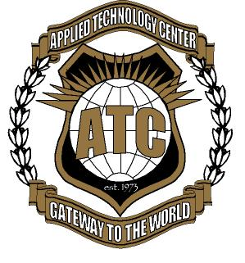
APPLIED TECHNOLOGY CENTER

In an effort to reduce costs and to continue to be a better global citizen, the Applied Technology Center will now provide all Parent and Student Forms online.
Please visit https://www.rock-hill.k12.sc.us/domain/1354 to review the various forms required by The Rock Hill School District. This form needs to be returned by all students of the Applied Technology Center.

I have received and read the following documents which are provided to me on the Applied Technology Center website:

Agree | Not Agree | Not Applicable | Forms
 |  |  | Computer Use Agreement
 |  |  | Job Work Sites Permission
 |  |  | Cell Phone Policy
 |  |  | Media Consent Form
 |  |  | Internet Assurances
 |  |  | Driver Permission Form
 |  |  | Class syllabus/expectations

Paper copies of the above forms are available from your student’s instructor if needed.

My daughter/son and I have discussed and understand the contents of these documents. We agree that she/he will abide by these expectations. Furthermore, if I have a question concerning this information, I understand that I may contact my child’s principal.

_________________________________________________________
Student Signature Print Student Name Date

Parent Signature Print Parent Name Date

