

PURCHASING PROCEDURES MANUAL

October 8, 2012
TABLE OF CONTENTS

PAGE
- INTRODUCTION 5
  - Introduction 5
  - Background 5
  - Purpose 5
  - Scope 5
  - Mission 6
  - Goals 6
  - Ethics 7

- ORGANIZATION STRUCTURE 9

- PROCUREMENT POLICIES 10
  - Development and Accountability 10
    - Purchasing Accountability 10
    - Department/School Accountability 11
    - Unauthorized Procurements 12
  - Purchasing Authority and Responsibility 12
    - Purchasing Director 12
    - Departments / Schools 13
    - Cooperative Purchasing 14
  - Prohibited Conduct 14
  - Retention of Records 15
  - Auditing 15

- PROCUREMENT METHODS 16
  - Small Purchases 16
  - Competitive Sealed Bidding 16
  - Exemptions 17
  - Sole Source Procurements 19
  - Emergency Procurements 20
  - District Contracts 21
  - State Term Contracts 21

- CONTRACTS 22
  - Use of District Contracts 22
  - Contracts / Agreements 22
  - Contract Administration 22

- SPECIFICATIONS 23
  - Performance Specifications 123
  - Design Specifications 23
  - Brand Name or Equal 24
  - Scope of Work for Services 24
  - Specification Do’s and Do Not’s 25

- COMPETITIVE SEALED BIDS 26
  - Procedures 26
  - Responsibilities 26
  - Determinations of Non-Responsiveness 27
  - Determination of Non-Responsibility 27
  - Confidentiality 27

- REQUEST FOR PROPOSAL 29
  - Procedures 29
  - Responsibilities 29
  - Confidentiality 30

- PURCHASE REQUISITION / PURCHASE ORDER 31
  - Purchase Requisitions 31
  - Purchase Orders 31
  - Requisition & Purchase Order Procedures 31
  - Blanket Purchase Agreement 32
  - Purchase Order Exemptions 33
  - Requisition Do’s and Do Not’s 34
  - Procurement Planning 34
  - PO Procedures in CSI 34

- VENDORS 43
  - Vendor Inquiry in CSI 43
  - New Vendor Request 46

- ACCEPTANCE OF GOODS & SERVICES 48
  - Inspection of Goods 48
  - Receiving Goods 48
  - Claims 49

- PAYMENT METHODS 51
  - Purchase Orders 51
  - Procurement Cards 51
  - Check Request Forms 51
  - Travel Reimbursements 51

- VENDOR PERFORMANCE 52
  - Vendor Relations 52
  - Vendor Grievances 52
  - Vendor Disbarment 52
  - Non-Compliance 52

- COOPERATIVE PURCHASING 53

- PROCUREMENT FUNDS MANAGEMENT 54
  - General funds 54
  - Non-Public Funds 54
  - Grants 54

- DISPOSITION OF SURPLUS PROPERTY 55
  - Procedures 55
  - Sales to Employees 55
  - Trade-In 55
  - Hazardous Materials 55
  - Security of Property 56
  - Allocation of Proceeds 56

- MINORITY BUSINESS 57
  - MBE Plan 57
  - Definition 57
  - MBE Liaison Officer 57
  - Fiscal Year Reporting 57

Glossary of Terms 58

- introduction
- INTRODUCTION
Procurement Services, under the general supervision of the Associate Superintendent of Administrative Services, is a support service for Rock Hill Schools, hereafter referred to as RHS. The function of this department is to oversee and assist departments and schools in acquisition of the many routine and different products and services required to operate and educate our children. Obtaining the proper product at the right price, in the right quantity and quality, from the right source, on time, and in compliance with all legal requirements, administrative policies, and ethical practices is our daily challenge.
- BACKGROUND
Public Procurement embraces a fundamental obligation to the general public to ensure that procurements are accomplished in accordance with the intent of the laws and administrative policies. Competition is sought to the maximum feasible degree. When conducted fairly and honestly, competitive procurement does not guarantee a preferred brand or vendor will be selected; instead the most favorable prices will be obtained for the quality level specified.
- PURPOSE
The purpose of this manual is:
- To inform all RHS personnel of the District’s procurement policies, procedures, and objectives.
- To outline practices, principles and procedures to be followed in the performance of the procurement function.
- To acquaint personnel of RHS with the purpose and functions of Procurement.
- To ensure standardization in procurement practices and procedures.
- SCOPE
The scope of the RHS Procurement Policies and Procedures Manual includes:
- The acquisition of goods, services, and equipment involving RHS funds to include:
- General Funds
- Capital Fund (Including Building Funds)
- Nutrition Service Fund
- Pupil Activity Funds (all Pupil Activity Funds are exempt from Code requirements)
- Federal Grant Funds
- State Grant Funds
- Purchases supported by parent groups, community groups, special interest booster groups when such funds are either deposited into District accounts or into school bank accounts
- The acquisition of goods, services, and equipment involving non-District funds when funds are deposited into RHS accounts, and therefore, become the responsibility of the RHS.
These policies/procedures do not apply to PTA, PTO, Booster Clubs or any other association or organization when the purchase is made directly by such organizations. Should a combined purchase by an association/organization and the District be made for which partial funding is supplied by the District, the Procurement Code would apply and District Procurement Procedures must be followed.
- MISSION
To conduct the procurement function in a manner which results in obtaining the most efficient and effective use of District funds. The Purchasing staff is dedicated to serving the District by coordinating its knowledge of markets and procurement techniques with its knowledge of the District’s requirements. The conduct of our office will be accomplished in accordance with ethical practices of the procurement profession. Activities and procedures of Procurement Services are regulated by and must comply with the RHS Procurement Code, policies of the Board of Trustees, all applicable state and federal laws, and the RHS Procurement Policies and Procedures Manual.
- GOALS
- To procure the highest quality goods and services at the best cost available.
- To provide assistance to departments and schools of RHS while enforcing the RHS Procurement Code and the District’s rules, policies and procedures concerning procurement.
- To conduct all procurement actions in a fair and impartial manner with no impropriety or appearance thereof.
- To provide assistance to administrators, department, and schools with selection of vendors, research, and resolving order problem issues as needed.
- To assist departments and schools in the preparation of specifications.
- To provide administrators, departments, and schools with the procurement tools, policies, procedures, and standards needed to accomplish their missions.
- To hold staff development sessions for personnel in the performance of their duties which relate to the purchase of goods and services.
- ETHICS
Public confidence in the integrity of RHS Procurement activities is critical. Improprieties, or even the appearance of improprieties, can undermine this confidence with very negative consequences. Erosion of trust by Rock Hill city taxpayers could result in decreased community support and revenues. Lack of trust by the vendor community could result in contract award protests or an unwillingness to submit bids, thus decreasing competition and potentially increasing the costs of goods and services.

The Procurement Services department has adopted the following National Institute of Governmental Purchasing (NIGP) Code of Ethics:

The Institute believes, and it is a condition of membership, that the following ethical principles should govern the conduct of every person employed by a public sector procurement or materials management organization.
- Seeks or accepts a position as head or employee only when fully in accord with the professional principles applicable thereto, and when confident of possessing the qualifications to serve under those principles to the advantage of the employing organization.
- Believes in the dignity and worth of the service rendered by the organization and the societal responsibilities assumes as a trusted public servant.
- Is governed by the highest ideals of honor and integrity in all public and personal relationships in order to merit the respect and inspire the confidence of the organization and the public being served.
- Believes the personal exaltation or personal profit obtained through misuse of public or personal relationships is dishonest and not tolerable.
- Identifies and eliminates participants of any individual in operational situations where a conflict of interest may be involved.
- Believes that members of the District and its staff should at no time or under any circumstances accept directly or indirectly, gifts, gratuities, or other things of value from suppliers which might influence or appear to influence Procurement decisions.
- Keeps the District informed, through appropriate channels, on problems and progress of applicable operations by emphasizing the importance of the facts.
- Resists encroachment on control of personnel in order to preserve integrity as a professional manager. Handles all personnel matters on a merit basis and in compliance with applicable laws prohibiting discrimination in employment on the basis of politics, religion, color, national origin, disability, gender, age, pregnancy and other protected characteristics.
- Seeks or dispenses no personal favors. Handles each administrative problem objectively and empathetically, without discrimination.
- Subscribes to and supports the professional aims and objectives of the National Institute of Governmental Purchasing, Inc.

II. organizational structure
Procurement Services consists of one (1) Director. The Purchasing Director reports to the Associate Superintendent of Administrative Services, who reports directly to the Superintendent.

- procurement policies
- DEVELOPMENT AND ACCOUNTABILITY
Rock Hill Schools has adopted operating procedures consistent with the policies of the Board of Trustees of the District in managing the commitment of funds entrusted to the District. The Purchasing Director has the responsibility to prescribe uniform procedures for requisitioning, receiving, transferring and accounting for supplies, materials, equipment and services in accordance with all applicable laws, rules, regulations, and policies. The procedures contained in this manual are applicable to all District personnel involved in the requisitioning, receiving, transferring and replacement of supplies, materials, equipment and services. The Associate Superintendent of Administrative Services is responsible for procurement oversight on Construction Projects.
The purchase of supplies, equipment, and services necessary for the operation of the District is the responsibility of the Procurement Department with some delegated authority to departments and schools within established dollar limits. The Procurement Department, departments, and schools are authorized to make commitments against District accounts for these purposes. It is the responsibility of each department/school administrator to ascertain that funds are available for purchases.
The Procurement Department, schools and all other departments, shall conduct the Procurement function in such a manner as to achieve the greatest benefit for the District in accordance with the ethical practices of the Procurement profession. Financial commitments inconsistent with the District’s Procurement Code and the State of South Carolina statues and policies shall not be made.
- PURCHASING ACCOUNTABILITY
A. The duties and responsibilities of the Procurement Department include, but are not limited to, the following:
- Administering all District policies, applicable procedures and reporting improprieties.
- Educating District personnel as to their responsibilities regarding procurement practices.
- Training all Department Heads, Principals and bookkeepers in the implementation and procedures of this manual.
- Determine the proper and most effective Procurement method for required supplies, equipment and services.
- Obtain competitive bids and proposals to the fullest extent possible and to prepare, in conjunction with departments and schools, complete specifications in order to release an Invitation for Bid (IFB) or Request for Proposal (RFP), for the required supplies, equipment, and services.
- Receive, open, tabulate, evaluate and recommend bids and requests for proposals that are in the best interest of the District.
- Administering the issuance of purchase orders and contracts issued by the District by monitoring vendor performance in conjunction with efforts by departments/schools and terminating contracts for cause when poor performance is documented.
- Review, analyze and approve, in conjunction with the Associate Superintendent of Administrative Services or Superintendent, or designee, emergency procurement and sole source procurement requests in accordance with the District’s Procurement Code.
- To coordinate and maintain all files and records as required by the District’s Board Policy and Procurement Code.
- Assist other departments and schools with the purchase of supplies, equipment, and services.
B. The District is not required to maintain a formal Bidders’ List. All formal solicitations will be advertised pursuant to the requirements of RHS Procurement Code. Vendors interested in doing business with Rock Hill Schools can monitor the District Web-Site for solicitations and awards
- DEPARTMENT/SCHOOL ACCOUNTABILITY
The Duties and responsibilities of the Principals and Department Heads include, but are not limited to, the following:
- To train all personnel in the implementation and procedures of this manual. The Procurement Services staff will be available to assist in this area.
- Insure that only authorized items and services are requisitioned and/or purchased and that all items purchased are shipped/delivered to the designated school/department. All purchases made with District funds for District use must be shipped/delivered to a District address.
- Insure that supplies, materials, and equipment are not requested or accumulated beyond actual needs.
- Insure that adequate planning and scheduling occurs at the department/school level to allow sufficient time for Procurement Services to schedule and perform their duties and responsibilities in timely manner.
- Receive supplies and materials in a timely manner to insure prompt payment.
- Reporting poor vendor and material/equipment performance to the Procurement Services for corrective action.
- Collaborating with the Purchasing Director in all contract negotiations.
The conservation, preventative maintenance, safeguarding, recovery, repair and salvage of supplies and equipment are the responsibility of all district personnel.
- UNAUTHORIZED PROCUREMENTS
Any purchase not made in accordance with the provisions of the District Procurement Policy and/or procedures will be considered unauthorized procurements. The Executive Director of Administrative Services will take corrective action on all unauthorized procurements. A written determination shall be made as to the facts and circumstances surrounding the act, corrective action taken to prevent reoccurrence, action taken against the individual committing the act, and documentation that the price paid is fair and reasonable.
- PURCHASING AUTHORITY AND RESPONSIBILITY
- Purchasing Director
The District’s Board of Trustees and the Superintendent have delegated to the Purchasing Director under the direction of the District’s Associate Superintendent of Administrative Services, the authority and responsibilities as follows:
- Enter into contracts for the procurement of goods and services as the Purchasing Director.
- Issuing, receiving, evaluating, and awarding informal competitive bids. All formal competitive bids are issued, received, and awarded by the Purchasing Director or Purchasing Agent, in accordance with the Rock Hill Schools Procurement Code.
- Administration of the Rock Hill Schools Procurement Card program in accordance with the District’s Procurement Code and the Procurement Card Policies and Procedures.
- The Purchasing Director is authorized to delegate procurement authority, or authorize exceptions from its procedures, to departments/schools for the procurement of specific goods and/or services. Authority to sign PO’s, contracts and agreements are delegated as follows:
- Department Administrators, or designee, in their absence (up to $2,500.00)
- Operations Director (up to $2,500)
- Food Service Director (up to $2,500)
- Principals, or designee, in their absence (up to $2,500.00)
- Purchasing Director (unlimited)
- Purchasing Agent (unlimited)
- Associate Superintendent of Administrative Services (unlimited)
- DEPARTMENTS/SCHOOLS
- The Purchasing Director delegates the authority to all departments/schools for Small Purchases up to $2,500.00 for the purchase of goods and services, in accordance with the procedures identified herein. At this level, the purchase order must be approved/signed by the Department Administrator/Principal, or their designee (in their absence), or the Purchasing Director.
- The Purchasing Director delegates the authority to all departments/schools for obtaining three (3) written quotes for solicitations from $2,500.00 to $10,000.00. All requisitions greater than $2,500.00 must be approved by the Purchasing Director, or designee. All PO’s greater than $2,500.00 must be approved by the Purchasing Director, or designee, and signed by the Purchasing Director or designee.
- Departments/Schools have the authority to enter purchase requisitions with unlimited dollar restrictions. (See Purchase Order Procedures section)
Note: Purchases cannot be divided (split) to circumvent any requirements herein.
This delegated authority shall not apply to signing vendor contracts or agreements. When exercising this delegated authority, the department/school administrator, or designee, signs as the “Authorized Purchasing Official” and certifies that goods and/or services are budgeted, appropriate and necessary.

- COOPERATIVE PURCHASING
The Purchasing Director shall have the authority to join with other SC School Districts, or other public procurement units, in cooperative purchasing plans when such purchasing is in the best interest of the District.
- PROHIBITED CONDUCT
No Rock Hill Schools employee having official responsibility for a procurement transaction will participate in that transaction on behalf of the District when the employee knows any or all of the following:
- The employee is contemporaneously employed by a bidder, offeror, or contractor involved in the procurement transaction.
- The employee, the employee’s partner, or any member of the employee’s immediate family holds a position with a bidder, offeror, or contractor such as an officer, director, trustee, partner or the like, or is employed in a capacity involving personal and substantial participation in the procurement transaction.
- The employee, the employee’s partner, or any member of the employee’s immediate family is negotiating or has an arrangement concerning prospective employment with a bidder, offeror, or contractor.
- No RHS employee or former RHS employee having official responsibility for procurement transactions shall accept employment with any bidder, offeror, or contractor with whom the employee or former employee dealt with in an official capacity concerning procurement transactions for a period of six (6) months from the cessation of employment with RHS unless the employee, or former employee, provides written notification to RHS prior to commencement of employment by that bidder, offeror, or contractor.
- No RHS employee having official responsibility for a procurement transaction shall knowingly falsify, conceal, or misrepresent a material fact, knowingly make any false, fictitious, or fraudulent statement or representations; or make or use any false writing or document knowing the same to contain any false, fictitious, or fraudulent statement or entry.
The penalty for violations of any of the above provisions is provided in the Ethics Government Accountability and Campaign Reform Act of the South Carolina Code of Laws. Violations of these provisions shall be grounds for loss of or reduction in authority delegated by the Board.
Procurement staff will not enter into any negotiations or become involved in any transactions for the purchase of anything for the personal use of RHS employees. Also, the purchasing power of the District (i.e., District contracts, State contracts, etc.) shall not be used to obtain goods and/or services for the private use of employees.
It is the responsibility of each employee of the Rock Hill Schools and Procurement Services to take all appropriate steps to assure that the School District does not knowingly enter into any purchase commitment, which could result in a conflict of interest. Procurement Services will bring any questionable situations to the attention of the proper authorities.
- RETENTION OF RECORDS
All procurement records of the RHS shall be retained on an active basis for a period of two (2) years then placed in storage for a retention period of three (3) years, then destroy.
Procurement records for all federally funded projects must be maintained for the year of funding, plus any carryover year, plus five (5) additional years. If any litigation claim, audit, or other action involving the records has not completed or resolved by the end of the five (5) years, the records shall be retained until completion of the action or resolution of all issues.
- AUDITING
The Procurement Services department shall be audited by the State Budget & Control Board or an independent audit firm (approved by the State Budget & Control Board) every three (3) years, minimum.

- PROCUREMENT METHODS
- SMALL PURCHASES
Purchases where the estimated total cost of the materials, equipment, supplies, and/or professional services is less than $50,000.00 shall be handled as follows:
- $0 - $2,500.00: (excluding SC sales tax, but including freight, installation, delivery, etc.) Quotations are not required if prices are considered to be fair and reasonable. Small purchases should be distributed equitably among qualified vendors. All small purchases must be annotated “Price is fair and reasonable”. When practical, a quotation must be solicited from other than the previous supplier before placing a repeat order. Purchases can be placed directly with the vendor by the end user through the CSI requisition/purchase order process. Procurement cards may be utilized for purchases less than $2,500.00.
- $2,500.01 - $10,000.00: (excluding SC sales tax, but including freight, installation, delivery, etc.) Solicitation of written quotations/bids from a minimum of three (3) qualified sources is required. Documentation of the written quotes must be attached to the Purchase Order. Award shall be made to the lowest responsive and responsible bidder.
- $10,000.01 - $50,000.00: (excluding SC sales tax, but including freight, installation, delivery, etc.) Requires written solicitation of written quotes, bids, or proposals. Must be advertised in SCBO (South Carolina Business Opportunities) or a paper of general circulation, or a means of central electronic advertising approved by the Board. A copy of the written solicitation and written quotes must be attached to the Purchase Order or made a part of the contract file. The award must be made to the lowest responsive and responsible source or the highest ranking offeror (when a Request for Proposal process is used).
- COMPETITIVE SEALED BIDDING
$50,000.00 and up: (excluding SC sales tax, but including freight, installation, delivery, etc.) Requires formal sealed bidding and public advertisement in SCBO (South Carolina Business Opportunities) or a paper of general circulation, or a means of central electronic advertising approved by the Board. After the public bid opening and award decision, when appropriate, a Notice of Intent to Award may be made. A formal bid process typically will take from 30 to 45 days.

- EXEMPTIONS
The RHS Board may exempt specific supplies or services from the Procurement procedures herein required or withdraw any exemptions provided for in this section. Purchases in excess of $2,500.00 that are exempt from the Quote/Bid/RFP process are as follows:
- Copyrighted Educational Materials to include, but not limited to:
  - Books, dictionaries, textbooks, newspapers, diplomas, sheet music
  - Professional journals, technical pamphlets, periodicals, subscriptions
  - educational films, filmstrips, slides and transparencies
  - video tapes, cassettes, DVDs
  - standardized testing materials
- Copyrighted Technology Materials to include, but not limited to:
- Computer-assisted instructional materials, interactive video programs
- CD-ROM documents, databases;
- District-adopted instructional software, including site licenses or other support services or related information/materials only available or provided by the software provider
- Medical and/or Psychological Services to include but not limited to:
- Licensed/certified medical doctors, physicians, nurses, psychiatrists, psychologists, school psychologists, behaviorists, counselors, optometrists, dentists, veterinarians, etc.
- Hospital and clinical services, occupational and physical therapy, orientation and mobility
- Speech, language and audiologist services
- Hepatitis B and other vaccines
- Governmental Services to include but not limited to:
- Services and supplies provided by the Federal government, State agencies, county, city or town governments, and special purpose Districts
- payments of taxes, social security, annuities, credit unions
- school resource officer services
- professional artists utilized by SC Arts Commission
- Educational Services to include, but not limited to:
- Contractual, cooperative agreements, services and supplies for provision of services to students
- Tuitions paid to institutions of higher education
- Evaluation services such as visiting committees of the Southern Association of Colleges and Schools
- Academic performance evaluation and consulting services
- Executive search and recruitment services
- Policy, Legal and Financial Services to include but not limited to:
- Attorney services (subject to Board or Superintendent approval), court recorders, expert witness services;
- Bond rating services
- Legislative consultant
- Advertising
- Primary and reinsurance coverage
- Goods and services of a confidential/sensitive nature that would cause injury to students, staff and/or District if procured through public solicitation, as recommended by administration and approved by Superintendent on a “as needed” basis
- Auditors (subject to Board or Superintendent approval); Substitute Staffing services
- Board Governance consultants and facilitators
- Securities Underwriters, Financial Advisors, and similar services provided by professionals regulated by the National Association of Securities Dealers (“NASD”)
- Staff Development to include but not limited to:
- Professional Services, training provided by consultants, certified teachers / trainers or District personnel;
- Training materials secured or prepared for instructional purposes;
- Workshop, conference, seminar registrations
- Travel
- Student Services to include but not limited to:
- Electronic and printed exams, tests, testing materials, including scoring services and materials
- Pupil Activity Funds;
- Canine drug and/or weapon detection services and related support services;
- Homebound services and home visits;
- Instruction provided by certified teachers
- Interpreters, interpreter services, tutors
- Professional dues and membership fees
- Clergy
- Travel
- Utilities and energy expenses to include, but not limited to:
- Fuel, propane, and natural gas
- Oil company credit card purchases of gas, oil or fluids
- Electric / power services
- Water, sewer services and related costs.
- art reproductions; emergency repairs for buses and fleet vehicles; items purchased for resale (i.e., school store items, yearbooks); livestock, feed and veterinary supplies; mail and delivery services; purchases and sales between South Carolina public school districts or state agencies
- Communication Expenses to include but not be limited to:
- Local & long distance telecommunication services
- Telecommunications equipment, upgrades, maintenance & repair contracts
- Lease of imbedded telephone systems
- Cell phones & services
- Refunds to include, but not be limited to:
- Refunds of health insurance, earnest monies, bid securities, or other funds temporarily entrusted to the District
- One of a kind items to include, but not be limited to:
- Paintings, sculptures, antiques, art reproductions, historical artifacts, and other rare items
- Scientific specimens, skeletal and taxidermy mounts, models, fossils, minerals, rocks etc.
- Emergency Repairs to include but not be limited to:
- Repairs to life safety, fire and security systems
- Repairs to busses or other vehicles while transporting students or staff on District sponsored trips

- Diplomas, Student Instruction Activities/Camps/Seminars, Yearbooks, Graduation Supplies, Class Rings, Fund Raisers and School Pictures
- Grant specified purchases
- Advertising at RHS Stadiums
- Perishable Foods (milk, fresh fruits, vegetables, meats, eggs, fish – any item with an expiration date)
- Goods and services provided by the Division of General Services
- Surplus items that are to be given/donated to other school districts, municipalities and governmental agencies
- All exemptions listed in SC Code Ann. 11-35-710 and all additional exemptions granted by the Budget and Control Board
Note: Exempt supplies and services are subject to all other sections of the District Procurement Code and these procedures (including requiring Purchase Orders).
- SOLE SOURCE PROCUREMENTS (Greater than $2,500.00)
Sole Source procurements are those in which the needs of the District can only be met by one (1) item or method and can only be obtained from one (1) source of supply.
- The following are conditions that could necessitate a Sole Source procurement:
- Where the compatibility of equipment, accessories, or replacement parts is of paramount consideration;
- A unique item is needed for trial use, or testing;
- Where the item is one of a kind.
A written determination must be made and a Purchase Order is required for all Sole Source Procurements. Sole Source Procurements must be approved in advance by the department/school administrator, Purchasing Director and the Superintendent or Associate Superintendent of Administrative Services.
All Sole Source procurements will reported to the School Board on an annual basis.
- PROCEDURES
- Complete a Sole Source Procurement Request Form with a written determination/justification for the procurement, enter the Purchase Requisition into CSI and send Sole Source Procurement Request Form along with the Purchase Requisition number and any supporting documentation to the Purchasing Director.
- The Sole Source request will be reviewed by the Purchasing Director. Upon approval, the request will be forwarded to the Superintendent or Associate Superintendent of Administrative Services for approval/disapproval.
- Once approved, Procurement Services will approve and print the purchase order. The purchase order will be signed either by the Purchasing Director, the Associate Superintendent of Administrative Services, or the Superintendent.
- EMERGENCY PROCUREMENTS (Greater than $2,500.00)
- EMERGENCY PROCUREMENTS EXIST WHEN THERE IS
- A threat to public health or welfare;
- A threat to the safety of people or property;
- When normal daily operations are adversely affected.
Emergency Procurements shall be made with as much competition as is practicable under the circumstances.
Emergency Procurements are restricted to the immediate need. A Purchase Order is required for all Emergency Procurements. Emergency Procurements must be declared by the Superintendent, Associate Superintendent of Administrative Services, Director of Maintenance or Purchasing Director.
- DECLARATION
Declaration of an Emergency shall be made as follows:
- Operations/Maintenance Issues: To be declared / determined by the District’s Director of Maintenance.
- Non-Operations/Maintenance Issues: To be declared / determined by the Superintendent, the Associate Superintendent of Administrative Services or the Purchasing Director.
- PROCEDURES
- Upon declaration of an emergency, the Purchasing Department must be notified as soon as possible via phone call or email. When feasible, three (3) written quotes must be solicited. The responsive and responsible bidder can be given Notice to Proceed .
- Complete an Emergency Procurement Request Form within twenty-four (24) hours of the determination of the emergency, or by close of the next business day, or as soon as possible, with a written determination/justification for the procurement. Enter the Purchase Requisition into CSI and send Emergency Procurement Request Form along with the Purchase Requisition number and any supporting documentation to the Purchasing Director.
- The Emergency Procurement request will be reviewed by the Purchasing Director. Upon approval, the request will be forwarded to the Associate Superintendent of Administrative Services, or his/her designee, for approval.
- Once the request is approved, the Purchasing Department will approve and print the purchase order. The purchase order will be signed either by the Purchasing Director or the Associate Superintendent of Administrative Services.
- DISTRICT CONTRACTS
Procurement Services specifically procures these contracts either for District-wide purposes or for a specific department/school. The District contract number (bid solicitation number) must be entered on the purchase requisition by notating “District Contract # ------------------------“. (The District contract number must be printed on the face of the purchase order.)
Other Contracts classified as District Contracts are Cooperative Contracts that are contracts established by two or more public entities, combining their requirements in order to realize a volume cost advantage.
- STATE TERM CONTRACTS
The District has access to contracts established by the State of South Carolina. (Procurement processes/procedures have already been performed. No bidding required) These should be utilized when possible. The State contract number must be entered on the purchase requisition by notating “State Contract # ----------------“. (The contract # must be printed on the face of the purchase order.)
A listing of State Contracts can be found at http://www.procurement.sc.gov
10% Rule: If another vendor can provide the same product for 10% less than the contracted vendor and, after notification, if the contracted vendor will not agree to reduce his price by 10%, the department/school may purchase from the non-contracted vendor. The 10% Rule must be referenced on the PO and any applicable documentation included in the bid file.
V. CONTRACTS
A contract is a mutually binding legal relationship obligating the seller to furnish the supplies or services and the buyer to pay for them.
- USE OF DISTRICT CONTRACTS
Whenever the Procurement Department has assigned a contract for a particular commodity or service, departments and schools are encouraged to order from the contracts. These contracts are listed on the Purchasing Section of the District web-site.
- CONTRACTS/AGREEMENTS
- Only the Superintendent, Associate Superintendent of Administrative Services, Executive Director for Administrative Services and the Purchasing Director are authorized to sign contracts that bind the District for the purchase of goods, services, insurance or construction, unless Board Policy or the Superintendent makes a specific delegation or exemption.
- All other administrators are limited to signature approvals on contracts with a dollar value of $2,500.00 or less.
- Non-standard contract documents requiring approval and signature shall be processed as follows:
- The using department/school shall review the document and forward to Purchasing;
- The Purchasing Director or Associate Superintendent of Administrative Services shall approve if it is in accordance with District policies, District Procurement Code and contract law.
- Purchasing shall secure the signature of the Contractor, and if necessary, the Associate Superintendent of Administrative Services or the Superintendent. Purchasing will distribute the contract documents as necessary.
The Associate Superintendent of Administrative Services or the Purchasing Director must approve all contracts involving appropriated and non-appropriated funds.
- CONTRACT ADMINISTRATION
It is necessary that contracts be administered to ensure that vendors are complying with the terms and conditions of the contract. Purchasing is responsible for administration of contracts involving appropriated funds. Problems with vendor performance should be reported to the Purchasing Department.
- SPECIFICATIONS
The term “specification” refers to that portion of a solicitation that describes the characteristics of a commodity or service required by a using agency. It is used interchangeably with the terms, “purchase description”, “purchase specifications”, “purchase requirements”, “scope of work”, and “statement of work”. A specification may include requirements for samples, prototypes, inspection, testing, warranty and packaging. The specification portion of a solicitation should not contain bidding instructions, contractual terms and conditions, pricing formats or similar materials. Procurement Services will assist departments/schools in describing goods and services in a manner that will not only meet the customer’s needs, but that will also encourage competition.
The preferred types of specifications are as follows:
- PERFORMANCE SPECIFICATIONS
Performance specifications are preferred since they communicate what a product is to do, rather than how it is to be built. Performance specifications should include the following:
- A general description;
- Required performance characteristics (minimum/maximum) to include speed, storage, production capacity, usage, ability to perform a specific function;
- Operational requirements such as limitations on environment, water, or air cooling, electrical requirements;
- Site preparation requirements for which the contractor will be responsible, such as electricity, plumbing, or, for which RHS will be responsible;
- Compatibility requirements with existing equipment or programs;
- Conversion requirements for maintaining current equipment or system until switching to the new equipment or system;
- Installation requirements;
- Maintenance requirements;
- Supplies and parts requirements;
- Quantity and method of pricing;
- Warranty; and,
- Service location and response time.
- DESIGN SPECIFICATIONS
Design specifications involve dimensional and other physical requirements and concentrate on how a product is to be built rather than on what is should do. Architects and engineers typically prepare design specifications for construction or custom manufactured products. A design specification includes the following:
- Dimensions, tolerances, and specific manufacturing or construction processes;
- References to a manufacturer’s brand name or model number
- Use of drawings and other detailed instructions to describe the product.
- BRAND NAME OR EQUAL OR ALTERNATE
Brand name or approved equal or alternate is the most commonly used type of specification. A brand name may be used to convey the general style, type, character, and quality of the goods desired. Any good determined to be the equal of that specified by the District, considering quality, workmanship, economy of operation and suitability for the purpose intended, shall be accepted. A brand name cannot be considered restrictive to exclude other manufacturer’s products from consideration.
Bidders must indicate brand name, model, model number, size, type, weight, color, etc. of the item bid if not exactly the same as the item specified. Vendor’s stock number or catalog number is not sufficient to meet this requirement. If any bidder desires to furnish an item different from the specifically mentioned in the specifications, he/she shall submit with his bid the information, data, pictures, cuts, designs, etc., of the material he/she plans to furnish so as to enable the District to compare the material specified; and, such material will be given due consideration. The District reserves the right to insist upon and receive the items as specified, if submitted items do not meet the District’s standards for acceptance. The District reserves the exclusive right to determine approved alternates and such determination shall be final and binding upon all bidders.
An alternate product can be defined as being similar in form, fit, and function and may be substituted for the required items, with no advantages or disadvantages.
The most important part of preparing brand name bid specifications is the use of the product’s salient features. Salient features are the inherent qualities of the product that are required for the product to perform its intended application. These characteristics should be stated in the specification, and the alternate product must meet these requirements in order to be acceptable. Not all characteristics of a product typically can be categorized as salient features so it is important to identify those that truly are critical to the product’s acceptability.
- SCOPE OF WORK FOR SERVICES
The following is a list of the types of information that should be included in a scope of work for professional or other services.
- General Requirements: Describe the contractor’s responsibility to provide a service or produce a specific study, design, or report.
- Specific Requirements: Address the specific tasks, subtasks, parameters and limitations that must be considered in producing the service or final project. The following factors should be included:
- Details of work environment
- Minimum or desired qualifications
- Amount of service needed
- Location of service
- Definition of service unit
- Time limitations
- Travel regulations or restrictions
- Special equipment required
- Other factors affecting working environment
- Provided Materials or Services: List any plans, reports, statistics, space, personnel, or other RHS provided items that must be used by the contractor.
- Deliverables, Reports, and Delivery Dates: Identify the specific delivery dates for all documentation or other products the contractor must furnish. Be clear about the expectations for the contractor’s performance.
- SPECIFICATIONS DO’S AND DONT’S
DO:
- Use the word “shall” or “must” to describe a command or mandatory requirement;
- Use the words “should” or “may” to describe an advisory or optional requirement; and
- Be specific and detailed in presenting mandatory requirements.
DON’T:
- Present something as mandatory if it is really optional; and
- Write specifications or scope of work that restrict response to a single bidder/offeror.
Departments/Schools are responsible for coordinating with the Purchasing Department to develop specifications (for bids in excess of $10,000.00).

VII. COMPETITIVE SEALED BIDS
Competitive sealed bidding is the preferred method of acquisition due to its non-subjective nature. This method of procurement is used to establish annual contracts.
Competitive sealed bidding is required by RHS Procurement Code for purchases of goods and services estimated to cost in excess of $50,000.00. Award is made to the lowest responsible and responsive bidder whose bid complies with the specifications contained in the Invitation for Bid (IFB).
- PROCEDURES
- A written Invitation for Bid (IFB) must be issued.
- Provide public notice of the bid by advertising in the South Carolina Business Opportunities (SCBO) or a newspaper of general statewide circulation and posting on the District website.
- Bid opening must be public and held at the location, date and time as advertised and published in the IFB. Public announcement of all bids received must be made.
- Contract to be awarded to the lowest responsive and responsible bidder meeting the terms and specifications.
- RESPONSIBILITIES
- Departments/Schools are responsible for the following during the competitive sealed bid process:
- Submit a Request for Bid/Proposal Form with details and specifications describing the design or performance characteristics of the goods and services required;
- Review bids, along with Purchasing, to ensure that the offered products meet the specifications of the solicitation;
- Document reasons, based on specifications, why a bidder should not be considered for award, if necessary; and,
- Recommend award to the lowest responsive and responsible bidder meeting the specifications.
- Procurement Services is responsible for the following during the competitive sealed bid process:
- Prepare bid solicitation document based on the Request for Bid Form and specifications submitted by the using department/school to assure that the process is open, equitable and fair to all potential vendors;
- Issue the solicitation and advertise the sealed bid according to RHS Procurement Code requirements;
- Receive and secure bids prior to bid opening;
- Open bids at the location, date and time specified in the solicitation;
- Conduct evaluation of the bids to determine the apparent lowest responsive and responsible bidder;
- Provide copies of the apparent lowest responsive and responsible bid to the using Department/School for review; and,
- Recommend award to the lowest responsive and responsible bidder meeting the specifications.
- DETERMINATION OF NON-RESPONSIVENESS
Any bid which fails to conform to the delivery schedule or other material requirements of the solicitation (i.e., failing to sign the bid, incomplete required forms, and change in delivery terms, and offer for goods/services that did not comply with the bid specifications) may be determined as non-responsive. When a bid is declared non-responsive, a written determination must be made part of the bid file.
- DETERMINATION OF NON-RESPONSIBILITY
A bid may be declared non-responsible under the following example situations:
- Bidder is not a regular supplier of the goods or services offered.
- Bidder cannot comply with the required delivery or performance schedule.
- Bidder does not have a satisfactory record of performance as documented prior to receipt of bids.
- Bidder does not have satisfactory record of integrity, or bidder is currently debarred or suspended by the District or the State of South Carolina.
- Bidder does not have the necessary facilities, organization, experience, technical skills, or financial resources to fulfill the terms of the PO or the contract.
When a bidder is declared non-responsible, a written determination must be made part of the bid file.
- CONFIDENTIALITY
Once bids are publicly opened and reviewed by persons present at the bid opening, they become confidential and are not releasable to the public until the contract is awarded. Only the information disclosed by the Purchasing Director or designee at the bid opening is considered to be public information under the Freedom of Information Act, Chapter 4 of Title 30, until the notice of intent to award is issued. Should an award not be made, bid/proposal documents are not available for public review under FOIA.

VIII. REQUEST FOR PROPOSAL

Request for Proposals are issued when the District determines that competitive sealed bidding is neither practicable nor advantageous to the District. The RFP or competitive negotiation process is typically used when factors other than lowest price are either equally as important as or more important than costs; or, when there’s a lack of information about what is required.
Competitive sealed proposals are a source selection method for procurements with an estimated cost of $50,000.00 or greater. Award is based on an evaluation of specified criteria, including price, and is made to the offeror whose proposal is determined to be the most advantageous to the District.
- PROCEDURES
- A written Request for Proposals (RFP) must be issued.
- Provide public notice of the bid by advertising in the South Carolina Business Opportunities (SCBO) or a newspaper of general statewide circulation and posting on the District website.
- Receipt of proposals must be open to the public and held at the location, date and time as advertised and published in the RFP. Public announcement of names of vendors from which proposals are received must be made. No other information is to be disclosed at the opening.
- Contract to be awarded to the highest ranked responsive and responsible proposer meeting the terms and specifications of the solicitation.
- RESPONSIBILITIES
- Departments/Schools are responsible for the following during the competitive sealed bid process:
- Submit a Request for Bid/Proposal Form with details, requirements and any required specifications describing the characteristics of the goods and services requested;
- Prior to the closing date of the RFP, the Purchasing Director and the Administrator or designee submitting the request must develop a Selection Advisory Committee (SAC) to perform evaluations of proposals received. The committee should consist of both technical and administrative personnel, and if appropriate, should include user department staff and persons from other departments. Members of this committee shall not have any financial interest in or any personal relationship with any of the proposing firms.
- Procurement Services is responsible for the following during the competitive sealed proposal process:
- Prepare the RFP solicitation document based on the Request for Bid/Proposal Form and information submitted by the using department/school to assure that the process is open, equitable and fair to all potential vendors with the technical requirements being prepared separately from the costs;
- Issue the solicitation and advertise for proposals according to RHS Procurement Code requirements;
- Receive and secure proposals prior to date and time in the solicitation;
- Announce names of proposers only at the location, date and time specified in the solicitation;
- Reviews the proposals for responsiveness and responsibility then distributes copies to members of the SAC following a briefing and instructions on the evaluation process.
- Purchasing Director, or designee, shall act as an advisor to the Evaluation Committee.
- Selection Advisory Committee (SAC) is responsible for the following during the RFP process:
- Individually reviews and evaluates the technical proposals according to the evaluation criteria specified in the RFP. No other criteria can be used or considered.
- The SAC meets as a group and reaches a consensus on the technical ranking of the proposals. The costs rankings will be provided to the SAC by the procurement official upon completion of the technical ranking. Proposals are the re-evaluated and rank offerors based on the technical and costs proposals.
- Negotiations may be conducted with the highest ranked offeror.
- Assuming negotiations are successful, a recommendation for award is made to the Purchasing Director for action.
- CONFIDENTIALITY
Once proposals are publicly received, they become confidential and are not releasable to the public until a contract is awarded. Only the information disclosed by the Purchasing Director or designee at the public opening is considered to be public information under the Freedom of Information Act, Chapter 4 of Title 30, until the notice of intent to award is issued. Should an award not be made, bid/proposal documents are not available for public review under FOIA.

IX. PURCHASE REQUISITIONS/PURCHASE ORDERS
- PURCHASE REQUISITIONS
Purchase requisitions are used to begin the process of buying goods and services using appropriated and non-appropriated funds. The requisition serves to inform Purchasing of the needs of the department/school and to fully define the material or services requested.
- PURCHASE ORDERS
Purchase Orders provide written authorization for vendors to provide the goods and/or services described on the order. The product or service description, delivery conditions (if applicable), quantity, and price are all specifically listed on the order. The PO also confirms to vendors that funds have been encumbered to ensure payment after the goods or services have been received.
- PURCHASE REQUISITION/PURCHASE ORDER PROCEDURES
Orders should not be placed with a vendor until a purchase order number has been issued. Failure to do this will result in an Unauthorized Procurement.
- Purchase Orders less than $2,500.00: Note: All purchases less than $2,500.00 must be annotated “Price is fair and reasonable”. This acknowledgement must be printed on the face of the purchase order.
- Check budget status to be sure sufficient funds are available.
- Enter complete requisition in CSI and have department/school administrator (or his/her designee, in their absence) approve the order. Once approved, the purchase requisition becomes the purchase order.
- Have the department/school administrator, (or his/her designee, in their absence) sign the printed purchase order. Mail or fax the purchase order to the vendor, send a signed copy to Accounts Payable, and retain a copy for your files. Note: if purchase order is faxed to the vendor, do not duplicate the order by mailing a copy of the PO.
- File a copy of the signed purchase order, along with all supporting documents. These files are subject to review and audit.
- CSI purchase order approval and related assignment of a purchase order number is representative of the Administrator’s approval and acceptance of compliance responsibility.
- Purchase Orders from $2,500.01 - $10,000.00:
- Check budget to see if sufficient funds are available.
- Each department/school is responsible for obtaining three (3) written bids/solicitations, if required. Procurements that do not require competitive bids/solicitations must fall within one of the following categories: State Contract, District Contract, and Exemptions.
- The purchase requisition is to be entered into the CSI accounting system through remote entry.
- Send copies of the written quotations/bids on vendor letterhead, along with the purchase requisition number, to Purchasing for approval.
- The requisition will be reviewed for accuracy, availability of funds, contract number, etc. by Purchasing. Upon approval of the requisition, Purchasing will print the purchase order and forward a copy to the department/school and to Accounts Payable. If noted on the requisition, purchasing will fax or mail copies of purchase order to the vendor.
- Purchase Orders in excess of $10,000.00 (requiring competitive bids):
- Check to see if sufficient funds are available.
- Notify the Purchasing Director, or designee of the need, and forward any supporting documentation and specifications.
- Once the competitive bids process is complete, the Purchasing Director, or designee, will review the bids/proposals received to determine the lowest responsive and responsible bidder (or highest ranked proposer when RFP process is used) and will notify the buying department/school. Once an award is made and posted according to Procurement Code requirements, the purchase requisition will be entered into the accounting system by Purchasing. The PO will be printed and signed by the Purchasing Director or his/her designee and copies distributed as needed. A copy of the PO and all supporting documents must be maintained in the Procurement file for audit.
- Orders in excess of $10,000.00 NOT requiring competitive bids (i.e., State Contracts, District Contracts, Emergencies – except when bids are deemed appropriate, Sole Source and Exemptions):
- The purchase requisition is to be entered into the CSI accounting system through remote entry. If approved, Purchasing will print the purchase order, sign and distribute copies to vendor, using department/school, and Accounts Payable.
- BLANKET PURCHASE AGREEMENT
A blanket purchase agreement is a simplified method of filling anticipated repetitive needs for small quantities of supplies or services. Blanket agreements are not to be used to purchase equipment items. The agreement will cover a stipulated time period up to an aggregate amount. This method of procurement reduces costs in accomplishing small purchases by eliminating the need for individual purchase orders. Blanket purchase agreements shall include the following information:
- Name of vendor/contractor
- Order number
- Description of supplies or services furnished
- Aggregate amount of order
- Not to exceed total amount per order
- Persons authorized to request supplies/services against the agreement

- PURCHASE ORDER EXEMPTIONS
The following items/services are exempt from District Procurement and do not require a District purchase order:
    - Travel Reimbursements
    - Payments for use of activity buses
    - Postage/Shipping and Post Office Box Rental
    - Utility Bills (telephone, gas, electric, water)
    - Periodic payments for contracted equipment and/or services (i.e., service contracts on copiers and other equipment, etc.)
    - Dues and Subscription renewals
    - Workshop/Conference registrations fees
    - Field Trips
    - Athletic Contests/Payments
    - Fuel
    - Automobile tags/titles & any other DMV requirements
    - Legal Advertisements/Personnel Ads
    - Books/copyrighted educational materials purchased at conferences and workshops
    - Food/materials for Staff Development, In-Service, and Public, Community, and Professional Events
    - Food service invoices, a spreadsheet showing the breakdown of all charges will be attached to actual invoice and forwarded to Accounts Payable for payment.
    - Small Dollar Purchases ($2,500.00 or less) made with a District Procurement Card
- REQUISITION DO’S AND DON’TS
DO:
- Provide as much information as possible.
- Provide a description of function, performance, or technical characteristics, as appropriate.
- Obtain appropriate Purchasing Director approval before submitting request, if necessary.
- Contact Technology Department for assistance/advice on technology purchases.
- Contact Operations for assistance/advice on building/grounds purchases.
- Contact Procurement Services for assistance.
- Ensure that Administrators approve order requests/requisitions prior to issuing a PO.
- Communicate the importance of your request (i.e., grant funds, impact on instructional process, etc.).
DON’T:
- Divide requirements to fall under the competitive threshold ($ 2,500.00).
- Copy specifications verbatim from a vendor’s publication.
- Provide any information to any potential vendor during the bidding process.
- Authorize any vendor(s) to proceed without a valid purchase order.
- Obtain goods or services without a valid purchase order.
- PROCUREMENT PLANNING
Proper planning is an essential element of good procurement. The primary mission of the procurement function is to provide goods and/or services for departments/schools in the proper quantity, of the proper quality, at the right time and place needed, and at the lowest possible costs. It is therefore imperative that customers thoroughly plan for their needs. Determining in advance what is needed, how much, where, and when will assist Procurement Services in effectively and efficiently satisfying customer needs while obtaining quality products and services.
- PURCHASE ORDER PROCEDURES IN CSI
- Creating a Purchase Order in CSI: To enter a new purchase requisition in CSI you will need to make the following selections:
- Click Systems and scroll down to select Purchasing.
- Then you will select Process, which will pull up a drop-down that has additional selections. Select Enter/Edit Purchase Requisitions.
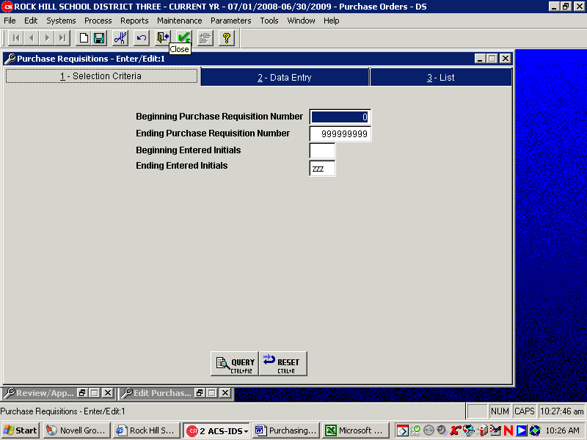
- You will make the following selections in the Enter/Edit Purchase Requisition screens:
- Click on the “New” icon located on the toolbar at the top of the screen (looks like a clean piece of paper with the top right corner folded down). The Enter/Edit Purchase Requisition screen will appear. (see next page for screen shot)
- Tab to the Vendor field & select the Vendor, either by number, if known, or by typing in a portion of, or, the entire name.
- Tab to Ship to and enter your appropriate location number.
- Enter the name of the person requesting the purchase.
- Enter the bid/quote information under Bid Info (must enter complete vendor name and bid/quote $ amount).
- In the Note field, enter any notes, contract #’s, expanded description, “Price is fair and reasonable” statement, etc. (this information can also be entered in the expandable note field under the Items Detail tab – right click in this field and choose zoom edit to enlarge the area)
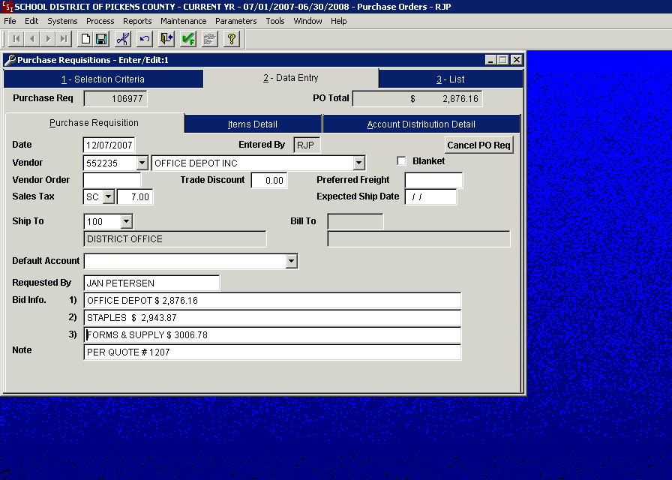
- Enter or Tab to Items Detail screen.
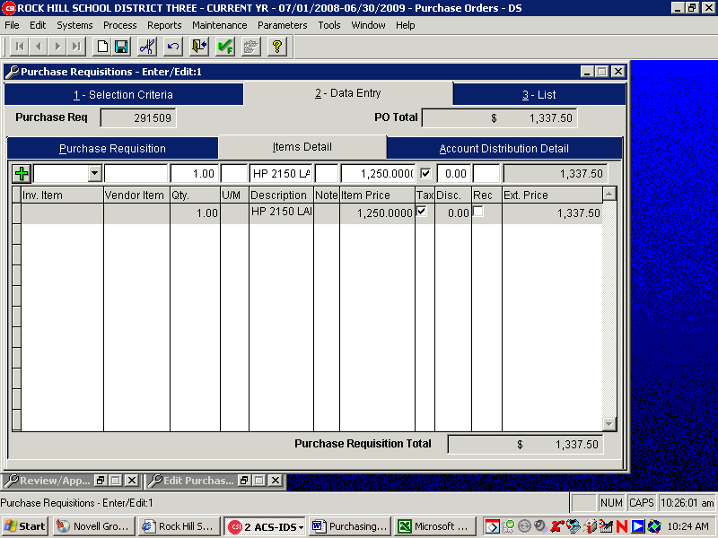

- Tab to Vendor item and enter the product/catalog #, if known.
- Tab to Qty. field and enter the quantity of item/service requested.
(10) Tab to U/M and enter the unit of measure (i.e. EA (each), PK (pkg), etc.)
(11) Tab to Description field and enter a COMPLETE description of the item or service requested. The description must satisfy audit requirements.
(12) Tab to Item Price and enter the unit price of the item or service.
(13) Enter until the total price appears in the extended price field.
(14) Enter again to add an additional line item (green plus will appear in top left corner) Only if adding additional line items.
(15) When this screen is complete, click on the Account Distribution Detail tab.
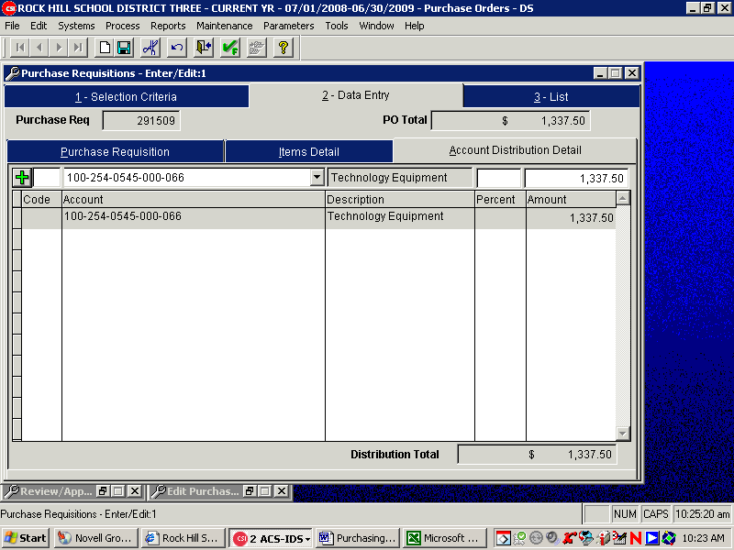
(16) If there are multiple account numbers, you will click on the “+” to add each account number (or “enter” after each preceding account has been entered until the green + appears) and the distribution amount related to that account. Click the “Save” icon on the tool bar (floppy disk) and the purchase requisition is complete.
(17) To enter a new requisition without exiting the enter/edit screen, click the “Finish” icon (green checkmark and F) on the tool bar. A new requisition screen will appear, with a new requisition number. Once all requisitions have been entered and you are ready to exit the Enter/Edit screen, click on the “Exit Door” icon (open door) on the tool bar.

- Reviewing and Approving a Purchase Requisition in CSI: To approve a purchase requisition in CSI you will need to make the following selections:
- Click Process, which will pull up a drop down that has additional selections. Select Review/Approve P.O. Requisitions.
- Enter the Purchase Requisition number in the Beginning Purchase Requisition Number field, click tab to Ending Requisition Number field and enter requisition number again, or, click F12.
- Click on the Query button at the bottom of the screen.
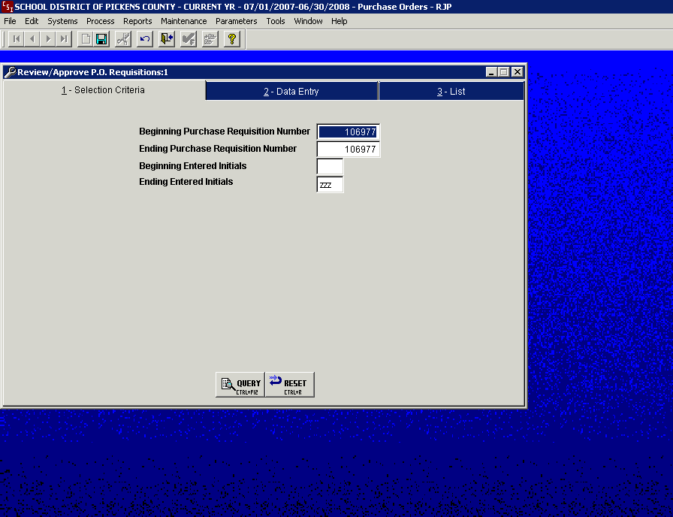
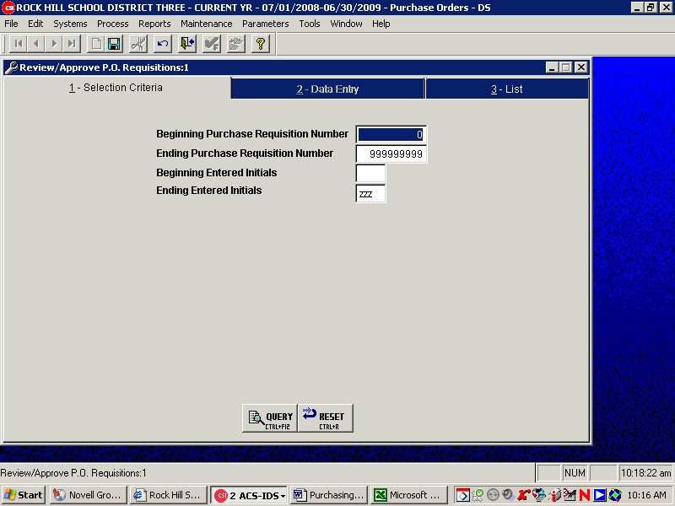
- Review the information in each field of the Purchase Requisition and if correct, click the single requisition “Approval” button on the top left hand of the Review/Approve PO Requisition screen (the first button with the green √ over one sheet of paper). If approving multiple, consecutively numbered requisitions at one time (verify that all requisitions showing for approval are yours by clicking on the “list” tab). If all requisitions are ok to approve click the multiple requisition “Approval” button at the top left (icon with green √ over multiple sheets of paper).
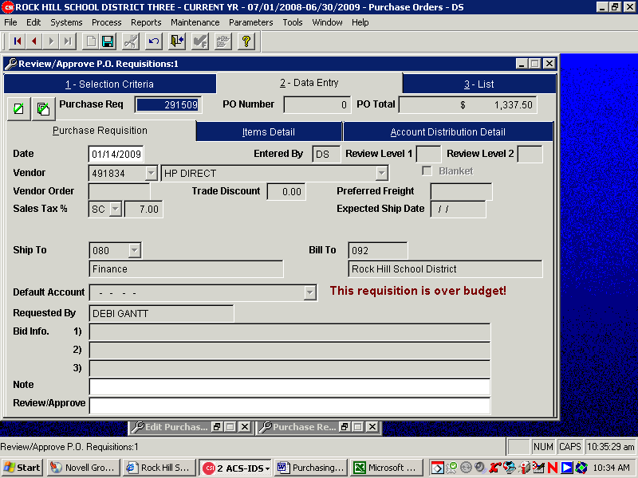
- Once you have approved the Purchase Requisition(s), a box will appear on the screen indicating that the system has assigned a Purchase Order Number to the Purchase Requisition(s). The assigned number(s) will serve as the actual Purchase Order Number(s) to be used with vendors. If multiple Purchase Requisitions are approved, the assigned Purchase Order numbers can be obtained by clicking on the list tab.
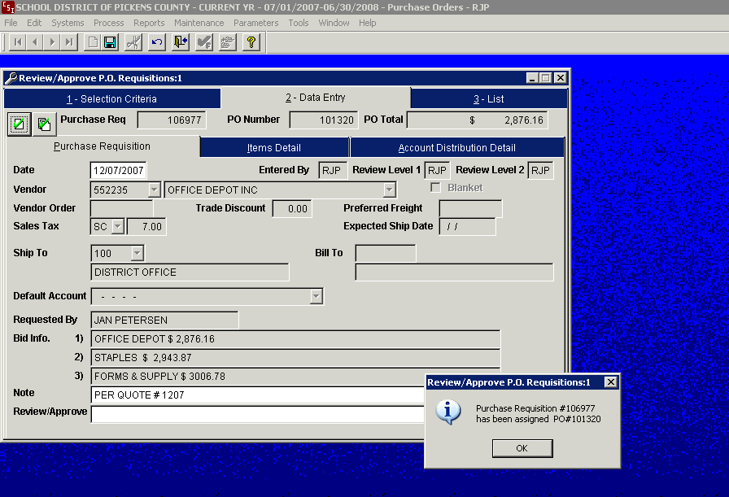
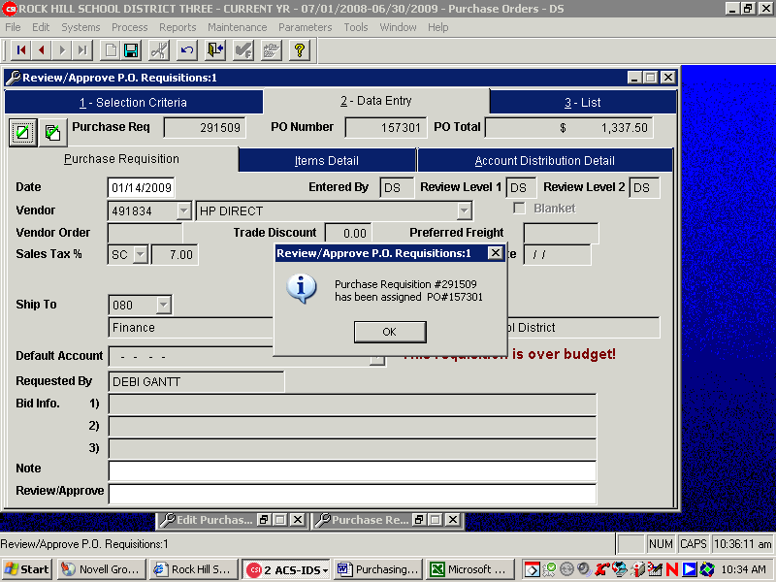

- Printing a Purchase Order: To print a Purchase Order, you will need to make the following selections:
- Click Process then select Print Purchase Orders.


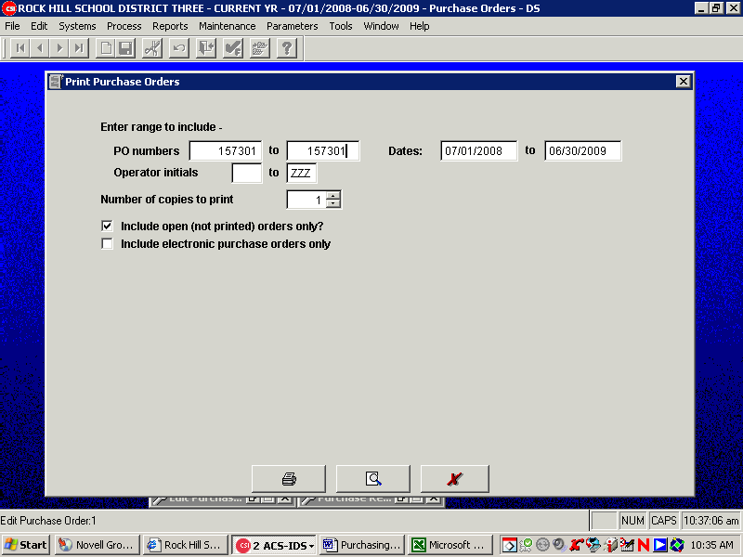

- Enter the Purchase Order number in the first PO numbers field and press the F12 on the second PO numbers field or, type the PO number in the second PO numbers field.

- Click the Printer or Preview icon at the bottom of the screen. Click Print Preview icon (magnifying glass over sheet of paper) if you want to preview the PO(s) to be printed, prior to the actual printing of the PO(s).
X. VENDORS
- VENDOR INQUIRY IN CSI
Prior to entering a purchase requisition into the CSI accounting system, a client has the ability to perform an inquiry for a specific vendor. Vendor inquiry procedures in CSI are as follows:
- Systems
- Accounting
- Accounts Payable
- Vendors
- Inquire Vendors

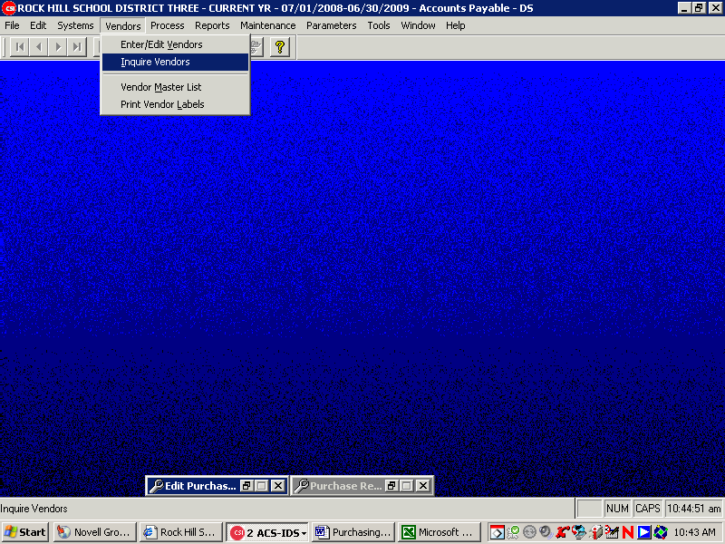
TAB 1) Selection Criteria
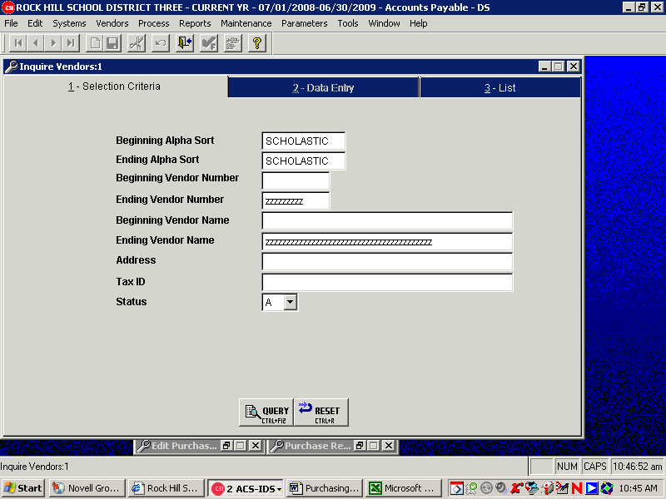
Beginning and ending Alpha Sort Type in the first several letters of the vendor you are inquiring

Defaults Leave all other fields at the program default

Query Choose query after completing the above selections. You may still have to narrow your selection by using tab 3 “list.”

Tab 2) Data Entry This screen displays the vendor information for the alpha selection on Tab 1. Vendors may need to be narrowed on tab 3 “list.”

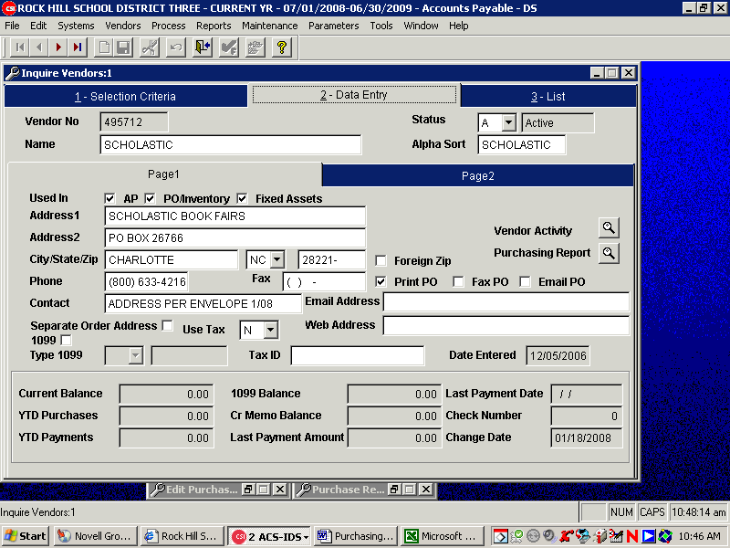
Tab 3) List
Highlight the vendor that you wish to inquire if you need to inquire. Then, return to tab 2 for detailed vendor information.

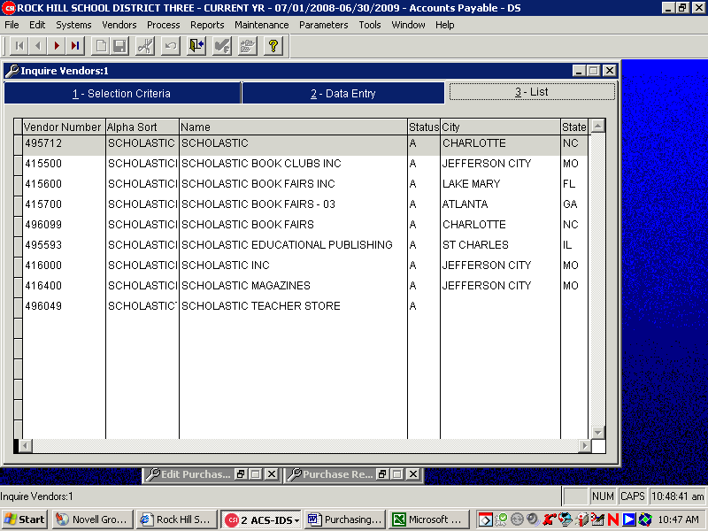

Tab down to the separate order address to view detail of address
- NEW VENDOR REQUESTS
Prior to Purchase Orders being issued or payments being issued to a vendor in the District’s accounting system, the vendor must be entered into the vendor database.
- PROCEDURES
- Client performs vendor inquiry in accounting software database.
- If vendor is already in database, client enters requisition into system.
- If vendor is not in system, client requests a completed W-9 form from vendor seeking to conduct business with. Client should also request the following information from the vendor:
- Phone Number (toll-free if available)
- Fax Number
- Email contact address
- Website Address
- Are they a SC Certified Minority Business? If yes, what is their certification number?
- Completed W-9 request and information should be sent to Accounts Payable for entry into the accounting software database. Notification will be sent to the client once vendor has been entered into database.

XI. ACCEPTANCE OF GOODS AND SERVICES
The Uniform Commercial Code states, “The Buyer has the right before payment or acceptance to inspect goods at any reasonable place or time.”
Departments/Schools of the District are delegated the authority and responsibility to inspect and accept goods and services on behalf of the District. It is imperative that the individuals exercising this responsibility assure that the quality and quantity received are the same as called for in the contract or purchase order. Goods and services must be delivered on time, as specified and in the proper quantity and quality.
- INSPECTION OF GOODS
- Verify quantity of packages delivered against PO. Inspect all containers and packages for external damage. Any unusual discrepancies, “rattles” or signs of leakage should be noted prior to signing the freight bill.
- Do not accept overage of a shipment unless the purchase order allows acceptance of a specified overage.
- If external damage is noted, the package should be opened immediately and the driver/deliverer along with the receiver should make a joint examination of the contents.
- A full, detailed report of the examination should be endorsed on the carrier’s delivery ticket as well as the department/school copy. Carrier should sign the department/school copy.
- Once merchandise is signed for, the carrier’s liability has technically ended, unless concealed damage is discovered within a reasonable time (usually within 10 days of delivery).
- Inspect the labels to ensure the merchandise is being delivered to the proper location.
- Within three (3) days, inspect the contents for concealed damage.
- Verify the packing slip with the delivery. Note date the supplies/services were received and sign the packing slip.
- Inspect the goods for compliance with the purchase order. Note any changes in quantity received and/or any information relating to damage or rejection on a valid copy of the PO.
- Move shipment to proper location from the receiving area as soon as possible and protect packages from weather and improper storage and handling procedures.
- RECEIVING GOODS
  - After inspection and verification that goods were received in good order, a receiving report will be generated in CSI.
    - Click on Systems, Purchasing, Process and then Enter Receipts.
    - Enter the purchase order number into Beginning PO # and tab to Ending PO # where you may either type in the number or hit F12 to duplicate.
    - Enter the quantity received and the date (you will have the option to backorder items if everything has not been received).
    - Print the receiving report and forward to Accounts Payable for processing. Do not send any packing slips, but if you have the actual invoice, please forward to AP with the Receiving Repot

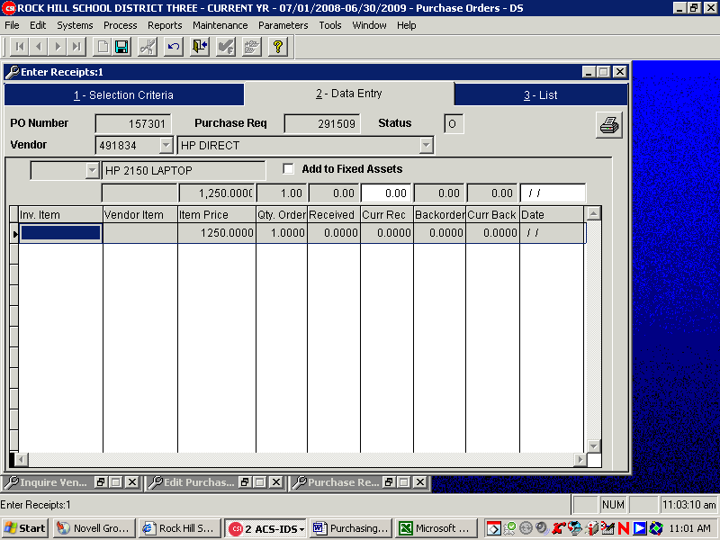

- CLAIMS
- If damage is such that the value of the goods is destroyed, the goods may be refused.
- If goods are accepted, steps should be taken to minimize damage and a claim filed with the vendor. While vendor is awaiting the carrier’s investigation of the claims, the goods should be left in the original container and moved only if absolutely necessary.
- File Claims Immediately: If the vendor is responsible for filing claims, it is imperative that the receiving department/school notify the vendor immediately and provide evidence to be used in the claim process. Digital pictures of the damaged goods are great documentation to support claims.
NOTE: Most District deliveries are made FOB Destination, which means the seller is responsible for filing claims for damaged goods. The seller must be notified immediately of the necessity for a claim and provided documentation and evidence to support the claim.
When the District is responsible for filing a claim: complete the claim form, supported by the original bill of lading, evidence of the freight charges and original invoice. Keep copies of all documentation for department/school records.
XII. PAYMENT METHODS
- PURCHASE ORDERS
The Accounts Payable Department is responsible for processing payments. This task is accomplished by matching Purchase Orders, vendor invoices, and receiving reports. If all three documents match within established tolerances, payment is made. If mismatches occur, accounts payable must research and resolve the mismatch before processing the payment. If any of the three documents are missing, they must be obtained prior to payment being processed.
- PROCUREMENT CARDS
RHS Procurement Cards are issued through Procurement Services and is a credit card used to provide an additional mechanism for enabling employees to acquire needed materials and services. All cardholders and bookkeepers/secretaries are provided training, as well as written guidelines and procedures, for use of a District procurement card.
The Procurement Card is a simplified and cost-effective method of purchasing and remitting payment for approved departmental/school expenditures under $2,500.00. The Procurement Card can be used for retail purchases as well as mail, telephone, fax or internet orders. For proper Procurement Card procedures, see RHS’s Procurement Card Policies and Procedures Manual. Procurement Cards are issued at the request of a District Administrator.
- CHECK REQUEST FORMS
There are two types of Check Request forms used by the District.
A “Request for Contracted Services” form is to be used for any persons doing a service for the District (these are typically 1099 vendors). This form should be filled out completely, attach the invoice and send to Accounts Payable.
A Request for Reimbursement Form is to be used for any invoices that have been received without the issuance of an authorized purchase order. These type payments may or may not constitute an Unauthorized Procurement. (Purchase orders should be issued in lieu of using this form)
NOTE: District employees cannot be reimbursed for payments made to non-employees for any services performed. The District is required to track all payments made to individuals providing a service to the District. Federal code requires the District to have an IRS Form 1099 on file for vendors/individuals paid for services.
- TRAVEL REIMBURSEMENTS
Individuals may be reimbursed by appropriated funds for authorized travel expenses incurred during the function of their job. )
XIII. VENDOR PERFORMANCE
All contracts and POs contain vendor performance requirements. These requirements typically include price, quantity, quality, delivery location, and delivery date. An important part of the procurement cycle is to ensure that the vendor’s performance is consistent with the requirements.
Assuring proper performance by vendors requires open communication and cooperation between departments/schools and Procurement Services. Timely action on the part of the department/school and Procurement is a prerequisite for enforcing the terms of a purchase order and contracts.
- VENDOR RELATIONS
Departments/Schools shall not extend favoritism to any vendor. Each order shall be placed on the basis of quality, price, and delivery, with past service being a factor if all other considerations are equal.
No employee shall endorse any product of any type or kind in a manner that will identify him in any was as an employee of the District.
- VENDOR GRIEVANCES
Any bidder or offeror may protest the award or decision to award a District bid/contract, by submitting a letter of protest in accordance with Article 17, Section 4210 of the RHS Procurement Code.
- VENDOR DISBARMENT
Vendors may be debarred or suspended from submitting bids to the District in accordance with Article 17, Section 4220 of the District’s Procurement Code.
- NON-COMPLIANCE
Failure by vendors to deliver on time, in the proper quantities, or to meet specifications is serious discrepancies that must be handled in a prompt, uniform and fair manner.
When a non-compliant circumstance becomes apparent, the department/school should promptly contact the vendor to request correction to the situation. A complete record should be made of the contact to include the name, title and telephone number of the person contacted and any promises made.
If vendor continues to be non-compliant after the initial contact, Procurement Services shall be notified and provided complete background information and details surrounding the non-compliance issue. Upon receipt of the information, Procurement Services will take the appropriate steps to ensure the problem is cured and maintain vendor concerns on file.
XIV. COOPERATIVE PURCHASING
Cooperative Purchasing is a process by which two or more jurisdictions cooperate to purchase items from the same vendor, under one contract. The form of Procurement has the benefits of reducing administrative costs, eliminating duplication of effort, lowering prices, sharing information and taking advantage of expertise and information that may be available in only one of the jurisdictions.
The Purchasing Director shall have the authority to join with other School Districts, the State of South Carolina, or other governmental entities in cooperative purchasing efforts when it is in the best interest of the District.
The District has the right to procure goods and services from the Office of General Services, Materials Management Office and Information Technology Office State Contracts when such procurements will serve the best interest of the District. Competitive sealed bids or sealed proposals received by another governmental agency or School District shall be the equivalent of bids or proposals received by this District and will be the basis for contract utilization by this District.
XV. PROCUREMENT FUNDS MANAGEMENT
Public Procurement by school districts is complicated in the facts that not only are there different procurement mechanisms; there are also different funding sources. There are public funds, which are appropriated by the School Board, pupil activity funds (non-public) generated from various fund raising and income generated activities at the school level, and grants (both federal and state funded).
- Department/School Administrators are given the authority to conduct their Procurement activities when expending public and non-public funds, in accordance to RHS guidelines and regulations.
- NON-PUBLIC FUNDS
Procurements for equipment, construction, architect-engineer services, construction management, and land surveying services using non-public funds must follow the same methods and procedures of procurement required of appropriated funds. All other procurements using non-public funds are exempt from the solicitation requirements of the RHS Procurement Code.
- GRANTS
The procurement of goods, services, construction, and equipment, which is acquired in whole or in part, through Federal and State Grant dollars is governed by the Office of Management and Budget (OMB) Circular A-102, Section 80.36 Procurement, which states, “States: When procuring property and services under a grant, a State will follow the same policies and procedures it uses for procurements from its non-Federal funds.”

XVI. DISPOSITION OF SURPLUS PROPERTY
The final step in the Procurement cycle is the disposition of surplus property – all District-owned supplies and equipment, not in actual public use, with remaining useful life and available for disposal.
- PROCEDURES
District property may be declared surplus by the Director of Maintenance, a department/school administrator, or the Purchasing Director when it is deemed unusable for District purposes, is obsolete, or the costs to repair or to refurbish the property in order to return it to public use would exceed the value of like used equipment with remaining useful life. Surplus property may be disposed of by public auction, competitive sealed bidding, or public sale. When an attempt is made to dispose of surplus goods through one or more of these methods and the goods are not sold, the goods will be discarded in a means of disposal most advantageous to the District.
- SALES TO EMPLOYEES
To ensure that there are no improprieties or appearances of impropriety, no item of District property shall be given to, leased, or sold to an employee of the District without there first having been a public announcement of the intended disposal of that property. No employee of the District shall receive any special or private consideration in the disposal of school property. Employees may acquire such property only as members of the general public.
- TRADE-IN
The Procurement Officer, in conjunction with the department/school may determine it is advantageous to see bids on replacement items with a trade-in allowance. The Purchasing Director has authority to approve trade-ins for items whose original unit purchase price did not exceed $5,000.00. The trade-in value must be applied to the purchase or lease of new like items. When the original unit purchase price exceeds $5,000.00, the Purchasing Director shall refer the matter to the Associate Superintendent of Administrative Services for disposition. The Associate Superintendent of Administrative Services shall have the authority to determine whether the property shall be traded in and the value applied to the purchase of new like items or classified as surplus and sold in accordance with the requirements of the Code for the disposal of surplus property. When the original purchase price exceeds $100,000.00, the Superintendent or his/her designee shall make a written determination as to its reasonableness and document such trade-in transaction.
- HAZARDOUS MATERIALS
There are strict State and Federal requirements for the disposal of hazardous materials. Departments/Schools which generate hazardous materials shall work with the Operations Department to determine appropriate action.
- SECURITY OF PROPERTY
Departments/Schools are responsible for the reasonable care and security of items declared surplus until the item(s) are either sold, or are transferred to another location within the District.
A continuous “paper trail” of accountability for all surplus items classified as fixed assets must be maintained. Fixed Asset records are located in the Finance Department under the direction of the Executive Director of Finance. This department is responsible for the development and maintenance of a fixed assets system to record and exercise reasonable control over all fixed assets owned by the District.
F. ALLOCATION OF PROCEEDS
The Executive Director of Finance shall deposit the proceeds of surplus sales in an expense account of the general fund or capital fund budget of the District
XVII. MINORITY BUSINESS
Contracts for supplies, services, equipment and construction may be negotiated with certified South Carolina minority firms in accordance with the provisions of the District’s Procurement Code and Regulations.
- MINORITY BUSINESS ENTERPRISE UTILIZATION PLAN
The South Carolina Consolidated Procurement Code contained in Sections 11-35-5210 et seq. of the Code of Laws of South Carolina (1976), as amended, requires that all State agencies that have adopted a procurement code that is substantially similar to the State code formulate a Minority Business Enterprise Utilization Plan (“MBE Plan”). The MBE Plan is designed to ensure that minority businesses are offered the opportunity to fully participate in the overall procurement process of the District.
- DEFINITION
The term “minority business” means a business holding a Certificate of Eligibility issued by the South Carolina Office of Small and Minority Business Assistance (OSMBA)
- MBE LIAISON OFFICER
The District’s Purchasing Director shall be the Liaison Officer for the District. All matters pertaining to the use of minority contractors and subcontractors shall be directed to the Liaison Officer.
- FISCAL YEAR REPORTING
Records shall be maintained to indicate the number and dollar value of purchases made from certified minority firms and reported in writing, to the Board annually.

Glossary of Terms

Act of God: A danger that could not be avoided by human power; any natural cause of damage which is irresistible (e.g. hurricane, flood, lightning), nad which is in no way connected with negligence.
Appropriation Legislative sanction to use public funds for a specific purpose: Money set apart for a specific use.
Arbitrary and Capricious Action: Action by whim or caprice; unreasoning action; ungoverned action; grounds for a court to overrule or remand an administrative decision or action.
As is: A term indicating that goods offered for sale are without warranty or guarantee, and that the purchaser takes the goods at his own risk without recourse against the seller for the quality or condition of the goods.
Authorized Price List: A price list of the products and/or services covered in a contract that contains minimum essential information needed by users placing orders.
Back Order: That portion of an order which a vendor cannot deliver at the scheduled time and which he has re-entered for shipment at a later date.
Best Interests of the District: A term frequently used in granting a procurement official the authority to use his/her discretion to take whatever action he/she feels is most advantageous to the District. The term is used when it is impossible to anticipate adequately the circumstances that may arise so that more specific directions could be delineated by law or regulation.
Bid: An offer, as a price, whether for payment or acceptance. A quotation specifically given to a prospective purchaser upon his request, usually in competition with other offerors. Also, an offer by a buyer to a seller, as at an auction.
Bid Award File: A file listing solicited bids, dates and the award. The bid award file is used to compare past bids for award patterns that might reveal collusive agreements or to make other comparisons of data.
Bid Bond: An insurance agreement in which a third party agrees to be liable to pay a certain amount of money in the event that a specific bidder, if his bid is accepted, fails to sign the contract as bid. (See Bid deposit; Bid security)
Bid Deposit: Sums of money or check, deposited with and at the request of the District, in order to guarantee that the bidder will, if selected, sign the contract as bid. If the bidder does not sign the contract, he forfeits the amount of the deposit. (See Bid bond; Bid security; Forfeiture of deposit or bond)
Bid Opening: The process through which the contents of bids are revealed for the first time to the District, to the other bidders, and usually to the public. (See Public bid opening)
Bidder: One who submits a competitively priced offer in response to an Invitation for Bid.
Bidder’s List: A list maintained by the Procurement authority setting out names and addresses of suppliers of various goods and services from whom bids, proposals, and quotations can be solicited. See Pre-qualification of bidders; Qualified bidder.
Blanket Purchase Order: A purchase arrangement in which the purchaser contracts with a vendor to provide the purchaser’s requirements for an item(s) or a service, on an as- needed and often over the counter basis. Such arrangements set a limit on the period of time they are to be valid and the maximum amount of money that may be spent at one time or within a period of time.
Boiler Plate: Colloquial designation for standard terms and conditions, usually preprinted, incorporated in an Invitation for Bid, Request for Proposal, or a contract or purchase order. See “General Provision.”
Bond: An obligation in writing, binding one or more parties as surety for another.
Brand Name: A product name that serves to identify that product as having been made by a particular manufacturer, a trade name.
Brand Name or Alternate Specification: A specification that cites brand names, model numbers, or other identifications as representing quality and performance called for, and inviting bids on comparable items or products of any manufacturer.
Brand Name Specification: A specification that cites a brand name, model number, or some other designation that identifies a specific product as an example of the quality level desired. See Equal.
Breach of Contract: A failure without legal excuse to perform any promise that forms a whole or part of a contract. See Forfeiture of deposit or bond.
Breach of Warranty: Infraction of an express or implied agreement as to the title, quality, content, or condition of a thing sold.
Bulk Procurement: Procurement in large quantities in order to reduce the price per unit of individual items.
Catalog: A listing of item identifications arranged systematically.
Caveat Emptor “Let the buyer beware”: A maxim stating the buyer should be careful in making a purchase because the burden of defective goods rests with him. In contravention, the seller can be held responsible for certain defects by means of suitable specifications, warranties, and contractual terms and conditions.
Caveat Venditor “Let the seller beware”: A maxim relating to situations where the vendor bears the responsibility for defects in the goods he sells.
Central Procurement Authority: The administrative unit in a centralized Procurement system with the authority, responsibility, and control of Procurement activities.
Centralized Procurement: A system of Procurement in which the authority, responsibility, and control of Procurement activities is concentrated in one administrative unit.
Change Order: A written order directing the contractor to make changes which the ‘Changes’ clause of the contract authorizes the purchaser to order without consent of the contractor.
Code of Ethics: A written set of guidelines within which judgments and considerations of professional ethics and behavior should be made. See: Procurement Ethics.
Collusion: A secret agreement or cooperation between two or more persons to accomplish a fraudulent, deceitful, or unlawful purpose.
Collusive Bidding: The response to bid invitations by two or more vendors who have secretly agreed to circumvent laws and rules regarding independent and competitive bidding.
Commodity: An article of trade, a moveable article of value, something that is bought or sold; any moveable or tangible thing that is produced or used as the subject of barter or sale.
Commodity Code: A numeric system used to represent words to describe a commodity, e.g. Class 410 Furniture, Hospital – Item 33, custom made.
Competition: The process by which two or more vendors vie to secure the business of a purchaser by offering the most favorable terms as to price, quality, and service.
Competitive Bidding: The offer of prices by individuals or firms competing for a contract, privilege, or right to supply specified services or merchandise.
Competitive Negotiation: A method for contracting for goods and services, whereby proposals are solicited from qualified suppliers, following submission of which changes in proposals and prices be allowed, and the offer deemed by the awarding authority to be most advantageous in terms of criteria as designed in the Request for Proposals is accepted; a negotiated purchase.
Competitive Quotations: The customary, and usually prescribed, method for making purchases involving dollar amounts less than that for which competitive sealed bidding is required. Law often calls for such competition, with the transactions designated as ‘informal bidding’ or ‘small purchases.’
Competitive Sealed Bid: A bid submitted in a sealed envelope to prevent disclosure of its’ contents before the deadline set for the receipt of all bids. Sealed bidding procedures on requirements of $50,000 or more. Competitive sealed bidding shall not be used to contract for professional services.
Confidential Information: (1) Any information which is available to an employee only because of the employee’s status as a public employee and is not a matter of public knowledge or available to the public on request. (2) Information, such as trade secrets and test data, which may be kept confidential in the Procurement process.
Conflict of Interest: A situation wherein an individual as part of his duties must make a decision or take action that will affect his personal interests. See ‘Code of Ethics’, ‘Procurement Ethics’.
Consideration: Acts, promises, or things of value exchanged by two parties that validates a contract between them.
Construction: Construction shall mean building, altering, repairing, improving or demolishing any structure of building and any drainage, dredging, excavation, grading or similar work upon real property.
Consultants and Experts: Those persons who are exceptionally qualified, by education or by experience, in a particular field to perform some specialized service. See: Professional Services.
Consulting Services: Advice or assistance of a purely advisory nature provided for a predetermined fee to a school/department by an outside individual, firm, or organization under contract to the District.
Contract: The total legal obligation that results from the parties’ agreement as affected by chapters 1 and 9 of this title and any other applicable rules of law. See: Agreement.
Contract Administration: The management of all facets of contracts to assure that the contractor’s total performance is in accordance with his contractual commitments and that the obligations of the purchaser are fulfilled. In government, this management is conducted within the framework of delegated responsibility and authority and includes the support of using agencies.
Contract Modifications: A written alteration in specifications, delivery point, rate of delivery, period of performance, price, quantity, or other provision of a contract accomplished pursuant to contractual conditions and leaving the general purpose and effect of the contract intact. See: Change Order.
Contract Record: A record providing particulars regarding the orders or releases placed for delivery of goods against a contract so the volume of contract purchases can be determined.
Contractor: One who contracts to perform work or furnish materials in accordance with a contract.
Contractual Services: Services furnished under a contract in which the nature and basis for charges and other pertinent contractual terms and conditions are defined. See: Services, Client Services, Professional Services, and Proprietary Services.
Convenience Termination Clause: A contract clause which permits the government to terminate, at its own discretion, the performance of work in whole or in part, and to make settlement of the vendor’s claims in accordance with appropriate regulations.
Cooperative Procurement: The combining requirements of two or more political entities in order to obtain the benefits of volume purchases and/or reduction in administrative expenses.
Corrupt Combination, Collusion, or Conspiracy in Restraint of Trade: Terms referring to an agreement between two or more businesses to stifle, control, or otherwise inhibit free competition in violation of state and/or federal antitrust laws or regulations. See Collusive Bidding, Price Fixing.
Cost Reimbursement: A contract under which a contractor is reimbursed for costs which are contract allowable and allocable in accordance with the contract terms and provisions of the procurement law, plus a fee, if any.
Cure Notice: A notice either oral or in writing that informs the contractor that he is in default and states what the contractor has to do to correct the deficiency. If the notice is oral it shall be confirmed in writing.
Damages: Compensation, usually in money, for injury to goods, persons or property.
Debarment: A shutting out or exclusion for cause (as a bidder from the list of qualified bidders). Failure by a party in a contract to comply with contractual requirements.
Default: Failure of a contractor to comply with the terms and conditions of a contract.
Delivery Schedule: The required or agreed to time and place of delivery.
Delivery Terms: Conditions in a contract relating to freight charges, place of delivery, and time of delivery.
Department: For the purpose of this manual, department means any department, division or office of the District.
Design Specification: A type or manner of writing a description of how the product is to be manufactured or work is to be performed; generic specification. Appropriate for a unique product or custom work.
Discount: An allowance or deduction granted by the seller to the buyer, usually when the goods are purchased. However, discounts may be granted by the seller; an example of such use of a discount is the application of discount to a nominal or “list” price to establish the ‘net’. See: Cash discount, Quantity discount, Standard package discount, and trade discount.
Emergency: A threat to life or property or an unforeseen situation that curtails or greatly diminishes an essential service as determined by the Superintendent, the Executive Director of Auxiliary Services, Maintenance Director, or the Purchasing Director.
Emergency Purchase: To obtain goods or services quickly to meet an emergency.
Equal: A phrase used to indicate the suitability of products of similar or superior function, purpose, design, and/or performance characteristics.
Equipment: Personal property of a durable nature which retains its identity throughout its life.
Ethics: Pertaining to or relative to moral action, conduct, motive or character; as ethical emotion; professional right or befitting; confirming to professional standards of conduct. See: “Code of Ethics”.
Evaluation of Bid: The process of examining a bid after opening to determine the bidder’s responsibility, responsiveness to requirements, and other characteristics of the bid relating to the selection of the winning bid.
Excess Property: Inventory not required by the owning agency, but of potential utility to one or more agencies of the jurisdiction or to others eligible to receive it by transfer.
Expedite: To hasten or to assure delivery of goods purchased in accordance with a time schedule, usually by contact by the purchaser with the vendor.
Expendable Supplies: Tangible supplies other than those treated as nonexpendable.
Express Warranty: Any affirmation of fact or promise made by a seller to a buyer that relates to the goods and becomes part of the basis of the bargain.
Fair Marker Value: A price that would induce a willing purchaser to purchase or a willing seller to sell in an open market transaction; the price a property would bring at a fair sale between parties dealing on equal terms.
Firm Bid: A bid that binds the bidder until a stipulated time of expiration.
Fiscal Year: A period of twelve consecutive months selected as a basis for annual financial reporting, planning, or budgeting.
Fixed Price Contract: A contract that provides for a price that does not change.
FOB Freight on Board: Determines when ownership transfers from the seller to the buyer.
FOB Shipping Point: Ownership transfers when item is placed with the transportation carrier.
FOB Destination: Ownership transfers upon delivery to buyer.
Formal Advertising: The placement of a notice in a newspaper or other publication according to legal requirements to inform the public that the District is requesting bids on specific purchases that it intends to make. See: “Legal Notice”.
Formal Bid or Offer: A bid that must be forwarded in a sealed envelope and in conformance with a prescribed format to be opened at a specified time.
Fraud: A positive act resulting from a willful intent to deceive another with the purpose of depriving him of his rights or property.
Generals Terms & Conditions: Standard clauses and requirements incorporated into all solicitations (IFB/RFP) and resulting contracts which are derived form laws, or administrative procedures. (Also called Boiler Plate)
Generic Specification: A specification identified by commodity type only.
Goods: All material, equipment, supplies, printing, and automated data processing hardware and software.
Good Faith: Honesty in fact in the conduct or transaction concerned.
Grant: The furnishing by a grantor of assistance, whether financial or otherwise, to a person or unit of government to support a program authorized by law. It does not include an award whose primary purpose is to procure and end product, whether in the form of supplies, services, or construction; a contract resulting from such an award is not a grant but a procurement contract.
Gratuity: A payment, loan, subscription, advance, deposit of money, services, or anything of more than nominal value, present or promised, unless consideration of substantially equal or greater value is received. See “Code of Ethics”.
Gratuitous Offer: An uninvited condition or provision submitted by a bidder or offeror; an unnecessary or unwarranted submission.
Informality: A minor defect or variation of the bid or proposal from the exact requirements of the IFB or RFP, which does not affect the price, quality, quantity, or delivery schedule for the goods, services or construction being procured.
Informal Bid: An unsealed competitive offer conveyed by letter, telephone, telegram, or other means.
Inspection: Critical examination and/or testing of items to determine whether they have been received in the proper quantity and in the proper condition and to verify that they conform to the applicable specification.
Inspection Report: A report to inform the procurement authority of the quality or condition of the items delivered.
Invitation for Bid: A request, verbal or written, which is made to prospective suppliers requesting the submission of a bid on commodities or services. This includes all documents, whether attached or incorporated by reference, utilized for soliciting bids.
Item: Any product, material, or service.
Late Bid or Proposal: A bid or proposal which is received at the place designated in the IFB after the hour established by the invitation as the time by which all bids or proposals must be received.
Latent Defect: A defect that could not be discovered by ordinary and reasonable inspection.
Lead Time: The period of time from date of ordering to date of delivery which the buyer must reasonably allow the vendor to prepare goods for shipment.
Lease: A contract conveying from one person (lessor) to another (lessee) real estate or personal property for a term in return for a specified rent or other compensation.
Lease Purchase Agreement: A rental contract in which the renting party’s periodic payments or parts thereof are applied both to fulfill the rental obligation and as installments for eventual ownership of the commodity upon completion of the agreement.
Legal Notice: The notice that is required by law. Legal notice for some purchases may be the posting of an announcement of the purchase in a public place, the notification of the appropriate bidders from the bidders list, a formal advertisement in a newspaper or newspapers, or a combination of these methods. See: “Formal Advertising”.
Life Cycle Costing: Technique, which considers operation, maintenance, acquisition price, and other costs of ownership in the award of contracts to ensure that the item acquired, will result in the lowest total ownership cost during the time the item’s function is required.
Line Item: A procurement item specified in the IFB for which the bidder is asked to give individual pricing information.
Liquidated Damages: A specific sum of money, set as part of a contract, to be paid by one party to the other if he should default on the contract.
List Price: The published price for an item that a vendor uses for informing customers and potential customers.
Lowest Responsive and Responsible Bidder: That bidder who is awarded a contract because his bid in unit price, total cost of operation, or value per dollar is lower than any of the bidders whose reputation, past performance, and business and financial capabilities are such that they would be judged by the appropriate government authority to be capable of satisfying the government’s needs for the specific contract. Virtually the same as “lowest and best bid”, “lowest responsive and responsible bidder”, and “most advantageous bid, price and other factors considered.”
Lump Sum: A price agreed upon between vendor and purchaser for a group of items without breakdown of the individual values; lot price.
Manufacturer: One who controls the design and production of an item, or produces an item from crude or fabricated materials, or assembles materials or components, with or without modification, into more complex items.
Material(s): Items required performing a function or used in a manufacturing process, particularly those incorporated into an end product or consumed in its manufacture.
May: Denotes the permissive.
Minority: An individual who is a citizen or lawful permanent resident of the U.S. who is:
- A “Black American”, a person having origins in any of the Black racial groups of Africa.
- A “Hispanic American”, a person of Spanish or Portuguese culture with origins in Mexico, Central or South America, or the Caribbean, regardless of race.
- An “Asian American”, a person having origins in any of the original peoples of the Far East, Southeast Asia, the Indian Subcontinent, or the Pacific Islands.
- A “Native American”, a person who is a member of, or is eligible to be a member of, a federally recognized Indian tribe. A “federally recognized Indian tribe” means an Indian tribe, band, nation, ranchero, pueblo, colony, or other organized group or community, including any Alaska native village, which recognized by the Secretary of the Interior on October 1, 1985, as having special rights and is recognized as eligible for the services provided by the United States to Indians because of their status as Indians, and any tribe that has a pending application for federal recognition on October 1, 1985.
- A “Physically disabled person”, a person who has a physical impairment, defect, disease, ailment or disability of a permanent nature which in any way limits the type of employment for which the person would otherwise be qualified.
Misrepresentation: A manifestation by words or other conducts that, under the circumstances, amounts to an assertion not in accordance with the facts.
Mistake in Bid: A miscalculation in composing a bid resulting in an incorrect price or other term that may affect the bidder’s eligibility to be awarded the contract.
Modification: Any formal revision of the terms of a contract.
Multiple Contract Award: The award of separate contracts to two or more bidders for the same commodities but for different geographic areas, different quantities or different conditions.
Multi Step Bidding: A two-phase process consisting of a technical first phase composed of one or more steps in which bidders submit technical offers not priced to be evaluated by the District, and a second phase in which those bidders whose technical offers are determined to be acceptable during the first phase have their price bids considered. It is designed to obtain the benefits of competitive sealed bidding by award of a contract to the lowest responsive, responsible bidder, and at the same time obtain the benefits of the competitive sealed proposals procedure through the solicitation of technical offers and the conduct of discussions to evaluate and determine the acceptability of the technical offers.
M/WBE: A minority owned business enterprise or a woman owned business enterprise or a combination minority and woman owned business enterprise.
Negotiation: A bargaining process between two or more parties, each with its own viewpoints and objectives, seeking to reach a mutually satisfactory agreement on, or settlement of, a matter of common concern.
Net Price: Price after all discounts, rebates, etc. have been allowed.
Net Terms: See discount.
No Bid: A response to an IFB stating that the respondent does not wish to submit a bid.
Non-Competitive Negotiation: The process of arriving at an agreement through discussion and compromise when only one source is practically available.
Non-Professional Services: Any services not specifically identified as professional services in the definition of professional services.
Obsolete Property: Inventory without utility, due usually to technological development and/or normal wear and tear. Obsolete property may be ‘scrap’ with some value because parts can be recovered and reused.
Offer: The act of one person that gives another person the legal power to create a contract to which both of them are parties; to perform such an act.
Offeror: A person who makes an offer in response to a Request for Proposal.
Official Responsibility: Direct administration or operating authority, whether intermediate or final, either exercisable alone or with others, personally or through subordinates, to approve, disapprove, otherwise direct action in the name of the public or private entity.
Open Market Purchase: A purchase, usually of limited dollar amount, which is made by buying from any available source, as opposed to buying from a bidder who has responded to an IFB.
Owned: For the purposes of determining whether a business is a minority or woman business enterprise, shall mean that the minorities or woman, as the context requires, shall possess an ownership interest of a minimum of 51%.
Performance Bond: A contract or guaranty executed subsequent to award by a successful bidder to protect the government from loss due to his inability to complete the contract as agreed. See: Forfeiture of deposit or bond.
Performance Specification: A specification setting forth performance requirements that have been determined to be necessary for the item involved to perform and last as required.
Perishable Goods: Goods that are subject to spoilage within a relatively short time.
Personal Property: Everything that is not real property, which is subject to ownership, and which has exchangeable value.
Personal Service: Infrequent, technical, or unique functions performed by an independent entrepreneur. Personal services contracts almost always run to individuals rather than partnerships, firms or corporations. The services performed frequently are not the fulltime occupation of the contractor. Examples of personal services contracts include translation, technical editing, and technical appraisal.
Political Subdivision: A subdivision of a State that is delegated certain functions of local government, and which can include counties, cities, towns, villages, hamlets, boroughs, and parishes.
Potential Bidder of Offeror: A person who, at the time the District negotiates and awards or proposes to award a contract, is engaged in the sale or lease of goods, or the sale of services, insurance or construction of the type to be procured under such contract, and who at such time is eligible and qualified in all respects to perform that contract, and who would have been eligible and qualified to submit a bid or proposal had the contract been procured through competitive sealed bidding or competitive negotiation.
Pre-Bid or Pre-Proposal Conference: A meeting held prior to the date of bid or proposal submittal, which disseminates to all bidders or proposers in attendance information to assist them in submitting a bid or proposal including, but not limited to information regarding the M/WBE requirements of the District.
Preference: An advantage in consideration for award of a contract granted to a vendor by reason of the vendor’s residence, business location, or business classification (small business).
Prepaid: A term denoting that transportation charges have been or are to be paid at the point of shipment.
Pre-Qualification of Bidders: The screening of potential vendors in which the district considers such factors as financial capability, reputation, management, etc. in order to develop a list of bidders qualified to bid on district contracts. See: “Bidders List”, “Qualified Bidder”.
Price: The amount of money that will purchase a definite quantity, weight, or other measure of a commodity.
Price Agreement: A contractual agreement in which a purchaser contracts with a vendor to provide the purchaser’s requirements at a predetermined price. Usually it involves a minimum number of units, orders placed directly with the vendor by the purchaser, and a limited duration of the contract (usually one year). See: “Blanket Order”, “Open-end Contract”, “Requirements Contract”, and “Term Contracting”.
Price Competition: The basis for awarding a contract solely on the consideration of price as submitted on competitive bids or as negotiated under competitive proposals.
Price Control: The fixing or restricting of prices, especially by a government agency.
Price Fixing: Agreements between competitors to sell at the same price, to adopt formulas for the computation of selling prices, to maintain specified discounts, to maintain predetermined price differentials between different quantities, types, or sizes of products, or other means of setting prices charged to the purchaser. See: “Collusive Bidding”, “Corrupt Combination”, “Collusion”, or “Conspiracy in Restraint of Trade”.
Price List: See “Price Schedule”.
Price Schedule: A list of prices applying to varying quantities or kinds of goods.
Procurement: The process of obtaining goods or services, including all activities from the preparation and processing of a requisition, through receipt and approval of the final invoice for payment. The acts of preparing specifications, making the purchase, and administering the contract are involved. See: “Procurement Cycle”.
Professional Behavior: See “Code of Ethics”.
Professional Service: Infrequent, technical, and/or unique functions performed by independent contractors whose occupation is the rendering of such services. While not limited to licentiates, the services are considered “professional,” and the contract may run to partnerships, firms or corporations as well as individuals. Examples of professional services include medicine and the medical arts, architectural and engineering services, management and systems consultation, research, and the performing arts.
Proprietary Article: An item made and marketed by a person or persons having the exclusive right to manufacture and sell it.
Proprietary Information: Information or data describing technical processes, mechanisms, or operational factors that a business wishes to keep from general public view in order to maintain competitive capabilities in the market. See “Trade Secret”.
Proprietary Services: Work by independent contractors where the process is more important than the product, if any. Proprietary service contracts usually run to partnerships, firms, or corporations rather than individuals and are usually awarded through competition. Examples of proprietary service contracts include janitorial and custodial, protection & security, maintenance & repair, and data processing service bureau.
Proper Quality: The quality level that is suitable to the functions to be performed.
Proposal: An offer made by one party to another as a basis for negotiations for entering into a contract.
Proposal Evaluation Criteria: Factors, usually weighted, relating to management capability, technical capability, and manner of meeting performance requirements, price and other important considerations used to evaluate which proposer in a competitive negotiation has made the most advantageous offer.
Proposer: A person submitting a proposal in response to a RFP.
Protest: A complaint about a governmental administrative action or decision brought by a bidder or vendor to the appropriate administrative section with the intention of achieving a remedial result.
Public Bid Opening: The process of opening and reading bids, conducted at the time and place specified in the Invitation for Bids and/or the advertisement, and in the view of anyone who wishes to attend. See: “Bid Opening”.
Public Record: All information about government activities that is available for public inspection.
Public Bid Opening: The process of opening and reading bids at the time and place specified in the IFB and in the presence of anyone who wishes to attend.
Purchase Description: The words used in a solicitation to describe the supplies, services, or construction to be purchased, including any performance, physical, or technical requirements. Unless the context requires otherwise, the terms “purchase description,” “purchase specification,” and “specification” may be used interchangeably.
Purchase Order: A purchaser’s document used to formalize a purchase transaction with a vendor. A purchase order, when given to a vendor, may contain statements as to the quantity, description, and price of the goods or services ordered; agreed terms as to payment, discounts, date of performance, transportation terms, and all other agreements pertinent to the purchase and its execution by the vendor. A purchase order constitutes acceptance of a bid, resulting in a contract.
Purchase Request: Information transmitted by using agency requesting the central Procurement office to issue a contract for a particular need or group of needs. The request may include, but is not limited to, a performance or technical description of the requested item, delivery schedule, transportation mode, criteria for evaluation, suggested sources of supply, and information related to the making of any written determination required by policy or procedure. See “Requisition,” or “Request for Procurement Authority.”
Purchasing Agent: An administrator whose job includes soliciting bids for purchases and making awards of purchase contracts, buyer.
Procurement Cycle: The cycle of activities carried out by a Procurement department in the acquisition of goods and services.
Procurement Ethics: Moral concepts and practices based on the principle that the public interest is paramount, applicable to the personnel of the Procurement Department and all other persons involved in the Procurement process, particularly with respect to the expenditure of government funds and relationships between public employees and sellers. See “Code of Ethics”.
Procurement Manuals: A formal collection of information and instructions relative to practices and procedures of the Procurement authority and using agencies.
Procurement Official: An administrative officer who directly oversees the activities of Procurement Agents and other aspects of property management that are joined as separate or subordinate sections under individual administrative control.
Procurement, Public: The process of obtaining goods and services for public purposes in accordance with law and procedures intended to provide for the economical expenditure of public funds.
Qualified Bidder: A bidder determined by the government to meet minimum set standards of business competence, reputation, financial ability, and product quality for placement on the bidders list. See: “Bidders List” and “Pre-qualification of Bidders”.
Qualified Products List: A specification which is developed by evaluating various brands and models of an item and listing those that are determined to be acceptable as the only ones for which bids may be submitted; an approved brands list.
Quality Assurance: A planned and systematic series of actions considered necessary to provide adequate confidence that a product that has been purchased will perform satisfactorily in service.
Quality Control: The procedures and policies used to ensure adequate quality of goods produced or received.
Quantity Discount: An allowance determined by the quantity or value of a purchase. See “Discount”.
Quotation: A statement of price, terms of sale, and description of goods or services offered by a vendor to a prospective purchaser; the stating of the current price of a commodity; the price so stated.
Request for Proposals: A solicitation of responses for goods and/or services for which the scope of work, specifications or contractual terms and conditions cannot reasonably be closely defined. Evaluation of a proposal is based on prior established criteria which may include but may not be totally limited to price.
Requirements Contract: A contract in which the vendor agrees to supply all the purchaser’s requirements that arise for an item or items within a specified period. See “Blanket Order”, “Open end Contract”, “Price Agreement”, or “Term Contract”.
Requisition: An internal document by which a using agency requests the Procurement Department to initiate a purchase.
Responsible Bidder or Offeror: A person who has the capacity in all respects to perform fully the contract requirements, and the integrity and reliability that will assure good faith performance. An individual or business which has submitted a bid, offer, proposal, quotation, or response, which has the capability in all respects to perform fully the contract requirements, and the integrity and reliability which will give reasonable assurance of good faith and performance.
Responsive Bidder: A person who has submitted a bid that conforms in all material respects to the Invitation for Bid. An individual or business that has submitted a bid, offer, proposal, quotation, or response which conforms in all material respects to the solicitation, including, but not limited to, compliance with any M/WBE requirements contained within the solicitation.
Restraint of Trade: The effect of contracts or combinations which eliminate or stifle competition, effect a monopoly, artificially maintain prices, or otherwise hamper or obstruct the course of trade and commerce as it would be carried on if left to the control of natural and economic forces.
Restrictive Specifications: Specifications that unnecessarily limit competition by eliminating items that would be capable of satisfactorily meeting actual needs.
Salvage: Property that is no longer useful as a unit in its present condition but has some value in addition to its value as scrap, usually because parts from it may be recovered and reused.
Sealed Bid: A bid that has been submitted in a sealed envelope to prevent dissemination of its contents before the deadline for the submission of bids; usually required by the Procurement authority on major purchases to ensure fair competition among bidders.
Services: Services shall mean any work performed by an independent contractor wherein the service rendered does not consist primarily of acquisition of equipment or materials, or the rental of equipment, materials and supplies.
Single Source: A single response to a competitive solicitation.
Small Business: A designation referring to a firm, corporation, or establishment that has a small number of employees, low volume of sales, small amounts of assets, or limited impact on the market, and is independent, i.e., is not an affiliate or subsidiary of a business dominant in its field of operation.
Sole Source Purchase: An award for a commodity or service to the only known capable supplier, occasioned by the unique nature of the requirement, the supplier, or market conditions.
Solicitation: The process of notifying prospective bidders or offerors that the jurisdiction wishes to receive bids for furnishing goods or services. The process may consist of public advertising, mailing Invitation for Bids, posting notices, telephone or telegraph messages to prospective bidders, or all of these.
Specification: Any description of the physical, functional, or performance characteristics, or of the nature of a supply, service or construction item. A specification includes, as appropriate, requirements for inspecting, testing or preparing a supply, service, or construction item for delivery.
Standard Specification: A specification established through a standardization process to be used for all or most purchases of the item involved.
Standardization of Specifications: The process of examining characteristics and needs for items of similar end usage and developing a single specification that will satisfy the need for most or all purchases for that purpose.
Stock: A supply of goods maintained on hand in a supply system to meet anticipated demands.
Storage: The holding of goods in a designated place for safekeeping; a space or a place for the safekeeping of goods.
Subcontractor: Any person providing goods and/or services to a prime contractor for profit if such goods and/or services are procured or used in fulfillment of the prime contractor’s obligations arising from a contract with Rock Hill Schools, except persons providing goods to a prime contractor whose contract with the District is for the provision of materials, equipment or supplies.
Supplemental Agreement: A contract addendum accomplished by mutual action of the parties, permissible under emergency purchases, construction work, sole source purchase and otherwise where competition is not required.
Supplier: A firm that regularly furnishes needed items to a business or government; a vendor supplies items that are consumed or expended in the course of being used.
Surplus Property: Property which is in excess of the needs of the District and which is not required for its foreseeable need. The property may be used or new, but possess some usefulness for the purpose for which it was intended or for some other purpose. It includes scrap, which is material that is damaged, defective, or deteriorated to the extent that it has no value except for its basic material content.
Tabulation of Bids: The recording of bids and bidding data that was submitted in response to a specific invitation for the purposes of comparison, analysis, and record keeping.
Technical Proposal: A proposal not priced which sets forth in detail that which a vendor proposes to furnish in response to a solicitation.
Technical Specification: Specifications that establish the material and performance requirements of goods and services.
Term Contracting: A technique in which a source or sources of supply are established for a specified period of time, usually characterized by an estimated or definite minimum quantity, with the possibility of additional requirements beyond the minimum, all at a predetermined unit price. See: “Blanket Order”, “Open End Contract”, “Price Agreement”, or “Requirements Contract”.
Termination for Convenience: The termination by the District, at its discretion, of the performance of work in whole or in part and makes settlement of the contractor’s claims in accordance with appropriate policy and procedure.
Termination for Cause: The cancellation of a contract because of the contractor’s failure to perform.
Terms and Conditions: A phrase generally applied to the rules under which all bids must be submitted and the terms that are included in most purchase contracts that are often published by Procurement authorities for the information of all potential bidders.
Terms of Payment: Purchase transactions require payment for the goods or services received, and with exception of an unusual exchange or barter agreement there are three basic payment terms: cash, open account, and secured account.
Testing: A phase of inspection, involving the determination by technical means of the physical and chemical properties of items, or compounds thereof, requiring not so much the element of personal judgment as the application of recognized and established scientific principles and procedures.
Title: The means whereby a person’s ownership of property is established.
Token Bid: A perfunctory offer by a bidder with no serious intent of being the successful bidder; usually submitted to maintain eligibility for the bidders list or as an act of collusion.
Uniform Commercial Code: Uniform statute law adopted by states for consistency and modernity in law governing commercial transactions.
Unit Price: The price of a selected unit of goods or service (e.g., price per ton, labor per hours, per foot).
Unit Price Extension: The calculation of the total price of goods by multiplying the price per unit by the number of units purchased.
Unresponsive Bid: See Non-Responsive Bid.
Unsuccessful Bidder: An offer whose bid is not accepted for reasons of price, quality, failure to comply with specifications, etc.
Unsealed Bid: An unsealed written offer conveyed by letter, fax or other means. The bids are normally opened and recorded as received.
Used Equipment: Equipment that has been previously owned and used and is offered “where is” “as is”. It does not include demonstration; factory rebuilt or remanufactured equipment marketed through normal distribution outlets.
Value Analysis: An organized effort to analyze the function(s) of products, systems specifications and standards, and practices and procedures, intended to satisfy the required function(s) in the most economical manner.
Vendor: An actual or potential supplier of goods and/or services.
Vendor File: The accumulated record maintained by the Procurement office relevant to his business relationship with the record of performance of contracts, correspondence, and the results of special purpose analysis.
Void: Without legal effect; unenforceable.
Waiver of Bids: A process authorized by law or rule whereby a government Procurement office may procure items without competitive bidding procedures because of unique circumstances related to a particular need or purchase.
Waiver of Mistake or Informality: The act of disregarding errors or technical nonconformities in the bid that do not go to the substance of the bid and will not adversely affect the competition between bidders.

